SM Management System



Bahria University Karachi Campus

Group Member

* Uzair Mehmood.

51739

51777

51751

51723

* Noman Ali Siddique
* Mohsin Ali
* Muhammad Asad

Submitted to:

**Engr. Saniya Shaikh / Engr. Bushra Fazal**

Contents

SM Management System 1

SM MANAGEMENT SYSTEM 3

**Introduction:** 3

**Working:** 3

**Functionality:** 3

**Sql Server Tables and Procedures:** 3

Admin: 3

User: 4

Employees: 5

Products: 5

Drivers: 6

Suppliers: 7

Vehicles: 8

Orders: 8

Delivery: 9

**Forms:** 10

Program.cs 10

Starting_form.cs 10

Login.cs 12

Admin_Panel.cs 14

User_Panel.cs 18

Register_Admin.cs 19

Manage_Admins.cs 21

Manage_Users.cs 25

Manage_Employees.cs 28

Manage_Suppliers.cs 32

Manage_Products.cs 35

Manage_Drivers.cs 40

Manage_Vehicle.cs 43

Show_Admins.cs 47

Orders.cs 48

Book_Order.cs 54

Home_Delivery.cs 57

# SM MANAGEMENT SYSTEM

### **Introduction:**

SM is Store Management System. Its Simple efficient and easy to use. To use this software, you must be login as user or admin. Admin can use all the feature while users have limited access. SM Management System will keep the financial record of the market.

××××-------- ××××--------××××--------××××

### **Working:**

To enjoy the whole functionality of S.M Management System you must be login as an admin. You can also login as an admin to have limited access to this software. Admin can manage employees. Add user accounts. Admin Can manage Products, Suppliers, Vehicles and much more while User have limited access.

××××-------- ××××--------××××--------××××

### **Functionality:**

* Admin and User Login.
* Manage Users.
* Manage Employees.
* Manage Drivers.
* Manage Products.
* Manage Supplier.
* Manage Vehicles.
* Manage Orders.
* Manage Home Deliveries.
* Place Order.
* Forgot Password

### **Sql Server Tables and Procedures:**

### Admin:

create table admins

(

Id int NOT NULL Identity,

Name varchar(50) NOT NULL,

primary key(Id),

[User Name] varchar(50) NOT NULL unique,

Password varchar(50) NOT NULL,

Email varchar(50) NOT NULL unique,

Address varchar(250) NOT NULL,

[Date Of Birth] Date Not NULL,

);

-----------------Show admin

create procedure pro_show_admins

AS

Select * from admins

Go

----------------Delete Admin

create proc pro_delete_admins

@Id int

AS

delete from admins where Id=@Id

Go

----------------Insert Admin

create proc pro_insert_admins

@Name varchar(50),@UserName varchar(50),@Password varchar(50),@Email varchar(50),@Address varchar(250),@DateOfBirth Date

AS

insert into admins values (@Name,@UserName,@Password,@Email,@Address,@DateOfBirth)

Go

----------------update Admin

create proc pro_update_admins

@Id int, @Name varchar(50),@UserName varchar(50),@Password varchar(50),@Email varchar(50),@Address varchar(250),@DateOfBirth Date

AS

update admins set Name = @Name ,[User Name] = @UserName, Password = @Password, Email = @Email, Address = @Address ,[Date Of Birth]= @DateOfBirth where Id = @Id

Go

----------------Search Admin

create proc pro_search_admins

@Name varchar(50)

As

Select * from admins where Name Like '%'+@Name+'%'

Go

---------------Admin Login

create proc pro_login_admins

@UserName varchar(50),@Password varchar(50)

As

Select count(*) from admins where [User Name] = @UserName And Password = @Password

Go

### User:

create table users

(

Id int NOT NULL Identity,

Name varchar(50) NOT NULL,

primary key(Id),

[User Name] varchar(50) NOT NULL unique,

Password varchar(50) NOT NULL,

Email varchar(50) NOT NULL unique,

Address varchar(250) Not Null,

[Date Of Birth] Date Not NULL,

);

-----------------Show users

create procedure pro_show_users

AS

Select * from users

----------------Delete Users

create proc pro_delete_users

@Id int

AS

delete from users where Id=@Id

Go

----------------Insert Users

create proc pro_insert_users

@Name varchar(50),@UserName varchar(50),@Password varchar(50),@Email varchar(50),@Address varchar(250),@DateOfBirth Date

AS

insert into users values (@Name,@UserName,@Password,@Email,@Address,@DateOfBirth)

Go

----------------update Users

create proc pro_update_users

@Id int, @Name varchar(50),@UserName varchar(50),@Password varchar(50),@Email varchar(50),@Address varchar(250),@DateOfBirth Date

AS

update users set Name = @Name ,[User Name] = @UserName, Password = @Password, Email = @Email, Address = @Address ,[Date Of Birth]= @DateOfBirth where Id = @Id

Go

----------------Search Users

create proc pro_search_users

@Name varchar(50)

As

Select * from users where Name Like '%'+@Name+'%'

Go

---------------User Login

create proc pro_login_users

@UserName varchar(50),@Password varchar(50)

As

Select count(*) from admins where [User Name] = @UserName And Password = @Password

Go

### Employees:

create table employees

(

Id int primary key identity,

Name varchar(50) NOT NULL,

Gender varchar(10) Not Null,

Email varchar(50) NOT NULL unique,

Address varchar(250) NOT NULL,

[Phone Number] varchar(20) NOT NULL unique,

[Date Of Birth] Date Not NULL,

Salary int not null

)

-----------------Show Employees

create procedure pro_show_employees

AS

Select * from employees

Go

--------------Delete Employees

create proc pro_delete_employees

@Id int

AS

delete from employees where Id=@Id

Go

----------------Insert Employees

create proc pro_insert_employees

@Name varchar(50),@Gender varchar(10),@Email varchar(50),@Address varchar(250),@Phonenumber varchar(20),@DateOfBirth Date,@Salary int

AS

insert into employees values (@Name,@Gender,@Email,@Address,@Phonenumber,@DateOfBirth,@Salary)

Go

----------------Update Employees

create proc pro_update_employees

@Id int,@Name varchar(50),@Gender varchar(10),@Email varchar(50),@Address varchar(250),@Phonenumber varchar(20),@DateOfBirth Date,@Salary int

AS

update employees set Name = @Name ,Gender= @Gender,Email = @Email, Address = @Address, [Phone Number] =@Phonenumber ,[Date Of Birth]= @DateOfBirth,Salary = @Salary where Id = @Id

Go

----------------Search Emloyees

create proc pro_search_employees

@Name varchar(50)

As

Select * from employees where Name Like '%'+@Name+'%'

Go

### Products:

create table products

(

Id int identity,

Name varchar(50) NOT NULL unique,

Quantity int Not null,

Price int NOT NULL,

Weight int not null,

Sid int NOT NULL,

Primary Key (Id),

Foreign Key (Sid) References suppliers(Id)

)

-----------------Show Products

create procedure pro_show_products

AS

Select * from products

Go

----------------Delete Products

create proc pro_delete_products

@Id int

AS

delete from products where Id=@Id

Go

----------------Insert Products

create pro pro_insert_products

@Name varchar(50),@Quantity int,@Price int,@Weight int,@Sid int

AS

insert into products values (@Name,@Quantity,@Price,@Weight,@Sid)

Go

----------------Update Products

create proc pro_update_products

@Id int,@Name varchar(50),@Quantity int,@Price varchar(250),@Weight int,@Sid int

AS

update products set Name = @Name, Quantity=@Quantity,Price=@Price,Weight = @Weight,Sid=@Sid where Id=@Id

Go

----------------Search Products

create proc pro_search_products

@Name varchar(50)

As

Select * from products where Name Like '%'+@Name+'%'

Go

----------------Increment Quantity

create procedure pro_decquantity_products

@Id int, @Quantity int

as

begin

Update products SET Quantity = Quantity - @Quantity where Id = @Id;

end

go

----------------Decrement Quantity

create procedure pro_incquantity_products

@Id int, @Quantity int

as

begin

Update products SET Quantity = Quantity + @Quantity where Id = @Id;

end

go

### Drivers:

create table drivers

(

Id int primary key identity,

Name varchar(50) NOT NULL,

Gender varchar(10) not null,

Address varchar(250) NOT NULL,

[Phone Number] varchar(20) NOT NULL unique,

[Date Of Birth] Date Not NULL,

)

-----------------Show Drivers

create procedure pro_show_drivers

AS

Select * from drivers

Go

----------------Delete Drivers

create proc pro_delete_drivers

@Id int

AS

delete from drivers where Id=@Id

Go

----------------Insert Drivers

create proc pro_insert_drivers

@Name varchar(50),@Gender varchar(10),@Address varchar(250),@Phonenumber varchar(20),@DateOfBirth Date

AS

insert into drivers values (@Name,@Gender,@Address,@Phonenumber,@DateOfBirth)

Go

----------------Update Drivers

create proc pro_update_drivers

@Id int,@Name varchar(50),@Gender varchar(10),@Address varchar(250),@Phonenumber varchar(20),@DateOfBirth Date

AS

update drivers set Name = @Name ,Gender = @Gender, Address = @Address, [Phone Number] =@Phonenumber ,[Date Of Birth]= @DateOfBirth where Id=@Id

Go

----------------Search Drivers

create proc pro_search_drivers

@Name varchar(50)

As

Select * from drivers where Name Like '%'+@Name+'%'

Go

### Suppliers:

create table suppliers

(

Id int primary key identity,

Name varchar(50) NOT NULL unique,

Email varchar(50) Not null unique,

Address varchar(250) NOT NULL,

Number varchar(20) Not Null unique,

Created Date Not Null,

)

----------------Show Suppliers

create procedure pro_show_suppliers

AS

Select * from suppliers

Go

----------------Delete Suppliers

create proc pro_delete_suppliers

@Id int

AS

delete from suppliers where Id=@Id

Go

----------------Insert Suppliers

create proc pro_insert_suppliers

@Name varchar(50),@Email varchar(50),@Address varchar(50),@Number varchar(20),@Created Date

AS

insert into suppliers values (@Name,@Email,@Address,@Number,@Created)

Go

----------------Update Suppliers

create proc pro_update_suppliers

@Id int,@Name varchar(50),@Email varchar(50),@Address varchar(50),@Number varchar(20),@Created Date

AS

update suppliers set Name = @Name, Email = @Email,Address=@Address,Number=@Number,Created=@Created where Id=@Id

Go

----------------Search Suppliers

create proc pro_search_suppliers

@Name varchar(50)

As

Select * from suppliers where Name Like '%'+@Name+'%'

Go

### Vehicles:

create table vehicles

(

Id int primary key identity,

Name varchar(50) NOT NULL,

Number varchar(20) Not null unique,

Company varchar(50) not null,

[Max Load] int not null,

[Date Of Purchase] Date not null,

)

-----------------Show Vehicles

create procedure pro_show_vehicles

AS

Select * from vehicles

Go

----------------Delete Vehicles

create proc pro_delete_vehicles

@Id int

AS

delete from vehicles where Id=@Id

Go

----------------Insert vehicles

create proc pro_insert_vehicles

@Name varchar(50),@Number varchar(20),@Company varchar(50),@MaxLoad int,@DateOfPurchase Date

AS

insert into vehicles values (@Name,@Number,@Company,@MaxLoad,@DateOfPurchase)

Go

----------------Update Vehicles

create proc pro_update_vehicles

@Id int,@Name varchar(50),@Number varchar(20),@Company varchar(50),@MaxLoad int,@DateOfPurchase Date

AS

update vehicles set Name = @Name,Number = @Number,Company = @Company, [Max Load] = @MaxLoad,[Date Of Purchase] = @DateOfPurchase where Id=@Id

Go

--------------Search vehicles

create proc pro_search_vehicles

@Name varchar(50)

As

Select * from vehicles where Name Like '%'+@Name+'%'

Go

### Orders:

create table orders

(

Id int primary key identity,

[Customer Name] varchar(50),

Booked Date not null,

[Total Weight] int not null,

[Total Price] int not null,

)

-----------------Show Orders

create procedure pro_show_orders

AS

Select * from orders

Go

----------------Delete Orders

create proc pro_delete_orders

@Id int

AS

delete from orders where Id=@Id

Go

----------------Insert Orders

create proc pro_insert_orders

@CustomerName varchar(50),@Booked Date,@TotalWeight int,@TotalPrice int

AS

insert into orders values (@CustomerName,@Booked,@TotalWeight,@TotalPrice)

Go

----------------Update Orders

create proc pro_update_Orders

@Id int,@CustomerName varchar(50),@Booked Date,@TotalWeight int,@TotalPrice int

AS

update orders set [Customer Name]= @CustomerName,Booked=@Booked,[Total Weight]=@TotalWeight,[Total Price]=@TotalPrice where Id=@Id

Go

----------------Search Orders

create proc pro_search_orders

@Name varchar(50)

As

Select * from orders where [Customer Name] Like '%'+@Name+'%'

Go

### Delivery:

create table delivery

(

[Delivery Id] int primary key identity,---------------------------------------

[Order id] int not null,

[Vehicle id] int not null,-----------------------------------------------------

[Customer Name] varchar(50) not null,

[Phone Number] varchar(20) not null,--------------------------------------------

Address varchar(250) not null,------------------------------------------------------

Date Date not null,

[Place By] varchar(50),

Foreign key ([Order Id]) References orders(Id),

Foreign key ([Vehicle Id]) References vehicles(Id),

)

-----------------Show Delivery

create procedure pro_show_delivery

AS

Select * from delivery

Go

----------------Delete Delivery

create proc pro_delete_delivery

@Id int

AS

delete from delivery where Id=@Id

Go

--------------Insert Delivery

create proc pro_insert_delivery

@Orderid int,@Vehicleid int,@CustomerName varchar(50),@PhoneNumber varchar(20),@Address varchar(250),@Date Date,@placeby varchar(50)

AS

insert into delivery values (@Orderid,@Vehicleid,@CustomerName,@PhoneNumber,@Address,@Date,@placeby)

Go

----------------Update Delivery

create proc pro_update_delivery

@Id int,@PhoneNumber varchar(20),@Address varchar(250)

AS

update delivery set [Phone Number]=@PhoneNumber,[Address]=@Address where [Delivery Id]=@Id

Go

----------------Search delivery

create proc pro_search_delivery

@CustomerName varchar(50)

As

Select * from delivery where [Customer Name] Like '%'+@CustomerName+'%'

Go

### **Forms:**

### Program.cs

using System;

using System.Collections.Generic;

using System.Linq;

using System.Threading.Tasks;

using System.Windows.Forms;

namespace SM_Management_System_DBMS

{

static class Program

{

/// <summary>

/// The main entry point for the application.

/// </summary>

[STAThread]

static void Main()

{

Application.EnableVisualStyles();

Application.SetCompatibleTextRenderingDefault(false);

Application.Run(new Starting_form());

}

}

}

### Starting_form.cs

using System;

using System.Collections.Generic;

using System.ComponentModel;

using System.Data;

using System.Drawing;

using System.Linq;

using System.Text;

using System.Threading.Tasks;

using System.Windows.Forms;

namespace SM_Management_System_DBMS

{

public partial class Starting_form : Form

{

public static string con = @"Data Source=DESKTOP-GES7BRU;Initial Catalog=SM_MANAGEMENT_SYSTEM_DBMS;Integrated Security=True";

public Starting_form()

{

InitializeComponent();

}

private void button1_Click(object sender, EventArgs e)

{

panel1.Visible = true;

panel2.Visible = false;

panel3.Visible = false;

button1.Visible = false;

timer1.Start();

}

private void timer1_Tick(object sender, EventArgs e)

{

progressBar1.Increment(1);

label1.Text = progressBar1.Value.ToString()+"%";

if (progressBar1.Value.ToString() == "50")

{

//panel1.Visible = false;

panel2.Visible = true;

panel3.Visible = false;

}

else if (progressBar1.Value.ToString() == "90")

{

//panel1.Visible = false;

//panel2.Visible = false;

panel3.Visible = true;

}

else if (progressBar1.Value.ToString() == "100")

{

this.Hide();

Login login = new SM_Management_System_DBMS.Login();

login.Show();

timer1.Stop();

}

}

private void progressBar1_Click(object sender, EventArgs e)

{

}

private void panel3_Paint(object sender, PaintEventArgs e)

{

}

}

}

### 

### Login.cs

using System;

using System.Collections.Generic;

using System.ComponentModel;

using System.Data;

using System.Drawing;

using System.Linq;

using System.Text;

using System.Threading.Tasks;

using System.Windows.Forms;

using System.Data.SqlClient;

using Microsoft.VisualBasic;

namespace SM_Management_System_DBMS

{

public partial class Login : Form

{

public static string username;

public Login()

{

InitializeComponent();

}

private void button_forgotpassword_Click(object sender, EventArgs e)

{

string password = "0111";

inputbox:

string pass = Interaction.InputBox("Input Password", "Password Entered", "Password", 250, 250);

if (pass == password)

{

this.Hide();

Manage_User manage_user = new Manage_User();

manage_user.Show();

}

else if (pass != password)

{

MessageBox.Show("Incorrectpassword", "Unexpected Error", MessageBoxButtons.OK, MessageBoxIcon.Error);

goto inputbox;

}

}

private void button_login_Click(object sender, EventArgs e)

{

if (radioButton_admin.Checked)

{

check_admin_credential();

}

else if (radioButton_user.Checked)

{

check_user_credential();

}

else

{

MessageBox.Show("Please Check Radio Button", "Error", MessageBoxButtons.OK, MessageBoxIcon.Information);

}

username = textBox_username.Text;

}

private void panel1_Paint(object sender, PaintEventArgs e)

{

}

private void checkBoxshowpassword_CheckedChanged(object sender, EventArgs e)

{

if (checkBoxshowpassword.Checked == true)

{

textBox_password.UseSystemPasswordChar = false;

}

else

{

textBox_password.UseSystemPasswordChar = true;

}

}

private void button1_Click(object sender, EventArgs e)

{

this.Hide();

this.Hide();

Register_Admin register_admin = new SM_Management_System_DBMS.Register_Admin();

register_admin.Show();

}

private void label1_Click(object sender, EventArgs e)

{

}

public void check_admin_credential()

{

using (SqlConnection sqlcon = new SqlConnection(Starting_form.con))

{

sqlcon.Open();

SqlDataAdapter sqlda = new SqlDataAdapter("exec pro_login_admins '"+textBox_username.ToString()+"','"+textBox_password+"'", sqlcon);

// SqlDataAdapter sqlda = new SqlDataAdapter("select count(*) from admins where [User Name]='" + textBox_username.Text + "'And Password ='" + textBox_password.Text + "'", sqlcon);

DataTable dtbl = new DataTable();

sqlda.Fill(dtbl);

if (dtbl.Rows.Count == 1)

{

this.Hide();

Admin_Panel admin_panel = new Admin_Panel();

admin_panel.Show();

}

else

{

MessageBox.Show("Incorrect Username or Password", "TryAgain", MessageBoxButtons.OK, MessageBoxIcon.Warning);

}

}

}

public void check_user_credential()

{

using (SqlConnection sqlcon = new SqlConnection(Starting_form.con))

{

sqlcon.Open();

SqlDataAdapter sqlda = new SqlDataAdapter("exec pro_login_users '" + textBox_username.ToString() + "','" + textBox_password + "'", sqlcon);

DataTable dtbl = new DataTable();

sqlda.Fill(dtbl);

if (dtbl.Rows.Count == 1)

{

this.Hide();

User_Panel user_panel = new User_Panel();

user_panel.Show();

}

else

{

MessageBox.Show("Incorrect Username or Password", "TryAgain", MessageBoxButtons.OK, MessageBoxIcon.Warning);

}

}

}

private void panel2_Paint(object sender, PaintEventArgs e)

{

}

}

}

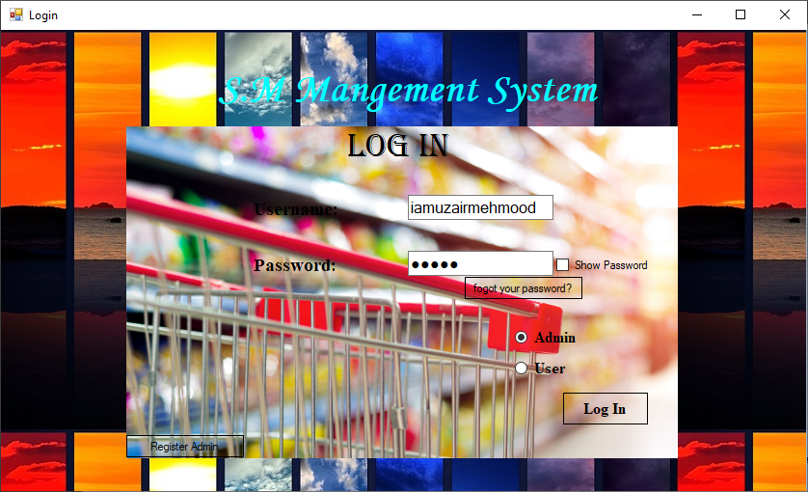

### Admin_Panel.cs

using System;

using System.Collections.Generic;

using System.ComponentModel;

using System.Data;

using System.Drawing;

using System.Linq;

using System.Text;

using System.Threading.Tasks;

using System.Windows.Forms;

namespace SM_Management_System_DBMS

{

public partial class Admin_Panel : Form

{

public Admin_Panel()

{

InitializeComponent();

}

private void button1_Click(object sender, EventArgs e)

{

}

private void Admin_Panel_MouseEnter(object sender, EventArgs e)

{

}

private void button1_mouseEnter(object sender, EventArgs e)

{

}

private void button1_MouseEnter(object sender, EventArgs e)

{

button1.FlatAppearance.BorderSize = 2;

button1.FlatAppearance.BorderColor = Color.Red;

}

private void button1_MouseLeave(object sender, EventArgs e)

{

button1.FlatAppearance.BorderSize = 1;

button1.FlatAppearance.BorderColor = Color.AliceBlue;

}

private void button1_Click_1(object sender, EventArgs e)

{

this.Hide();

Manage_Products manage_product = new Manage_Products();

manage_product.Show();

}

private void button2_MouseEnter(object sender, EventArgs e)

{

button2.FlatAppearance.BorderSize = 2;

button2.FlatAppearance.BorderColor = Color.Green;

}

private void button2_MouseLeave(object sender, EventArgs e)

{

button2.FlatAppearance.BorderSize = 1;

button2.FlatAppearance.BorderColor = Color.AliceBlue;

}

private void button3_Click(object sender, EventArgs e)

{

this.Hide();

Manage_Supplier manage_supplier = new Manage_Supplier();

manage_supplier.Show();

}

private void button3_MouseEnter(object sender, EventArgs e)

{

button3.FlatAppearance.BorderSize = 2;

button3.FlatAppearance.BorderColor = Color.Purple;

}

private void button3_MouseLeave(object sender, EventArgs e)

{

button3.FlatAppearance.BorderSize = 1;

button3.FlatAppearance.BorderColor = Color.AliceBlue;

}

private void Admin_Panel_Load(object sender, EventArgs e)

{

}

private void button4_MouseEnter(object sender, EventArgs e)

{

button4.FlatAppearance.BorderSize = 2;

button4.FlatAppearance.BorderColor = Color.DarkOrange;

}

private void button4_MouseLeave(object sender, EventArgs e)

{

button4.FlatAppearance.BorderSize = 1;

button4.FlatAppearance.BorderColor = Color.AliceBlue;

}

private void button5_MouseEnter(object sender, EventArgs e)

{

button5.FlatAppearance.BorderSize = 2;

button5.FlatAppearance.BorderColor = Color.DarkTurquoise;

}

private void button5_MouseLeave(object sender, EventArgs e)

{

button5.FlatAppearance.BorderSize = 1;

button5.FlatAppearance.BorderColor = Color.AliceBlue;

}

private void button2_Click(object sender, EventArgs e)

{

this.Hide();

Manage_Employees manage_employees = new Manage_Employees();

manage_employees.Show();

}

private void button4_Click(object sender, EventArgs e)

{

this.Hide();

Manage_User manage_users = new Manage_User();

manage_users.Show();

}

private void button5_Click(object sender, EventArgs e)

{

this.Hide();

Manage_Vehicle manage_vehicle = new Manage_Vehicle();

manage_vehicle.Show();

}

private void button6_MouseEnter(object sender, EventArgs e)

{

button5.FlatAppearance.BorderSize = 2;

button5.FlatAppearance.BorderColor = Color.DarkBlue;

}

private void button6_Click(object sender, EventArgs e)

{

this.Hide();

Manage_Drivers manage_drivers = new Manage_Drivers();

manage_drivers.Show();

}

private void button6_MouseLeave(object sender, EventArgs e)

{

button5.FlatAppearance.BorderSize = 1;

button5.FlatAppearance.BorderColor = Color.AliceBlue;

}

private void button8_MouseEnter(object sender, EventArgs e)

{

}

private void button7_MouseEnter(object sender, EventArgs e)

{

button7.FlatAppearance.BorderSize = 2;

button7.FlatAppearance.BorderColor = Color.DarkViolet;

}

private void button7_MouseLeave(object sender, EventArgs e)

{

button7.FlatAppearance.BorderSize = 1;

button7.FlatAppearance.BorderColor = Color.AliceBlue;

}

private void button7_Click(object sender, EventArgs e)

{

this.Hide();

Manage_Admins manage_admins = new Manage_Admins();

manage_admins.Show();

}

private void button_back_Click(object sender, EventArgs e)

{

this.Hide();

Login login = new Login();

login.Show();

}

private void button8_Click(object sender, EventArgs e)

{

this.Hide();

Book_Order save_order = new Book_Order();

save_order.Show();

}

}

}

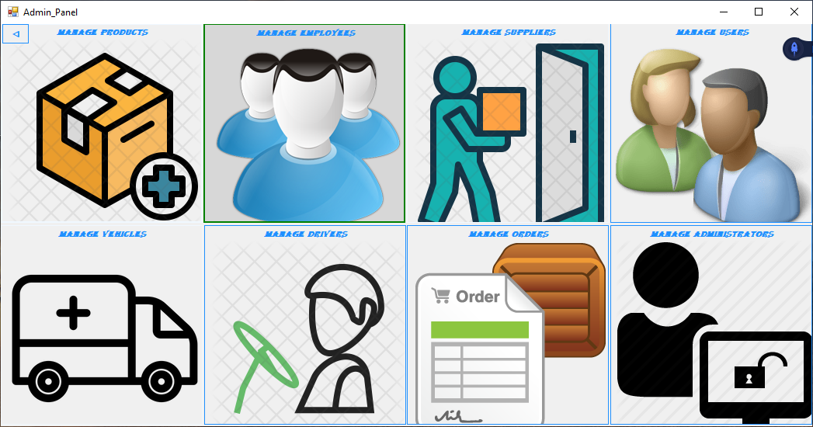

### 

### User_Panel.cs

using System;

using System.Collections.Generic;

using System.ComponentModel;

using System.Data;

using System.Drawing;

using System.Linq;

using System.Text;

using System.Threading.Tasks;

using System.Windows.Forms;

namespace SM_Management_System_DBMS

{

public partial class User_Panel : Form

{

public User_Panel()

{

InitializeComponent();

}

private void User_Panel_Load(object sender, EventArgs e)

{

}

private void button8_Click(object sender, EventArgs e)

{

this.Hide();

Order order = new Order();

order.Show();

}

private void button_back_Click(object sender, EventArgs e)

{

this.Hide();

Login login = new Login();

login.Show();

}

}

}

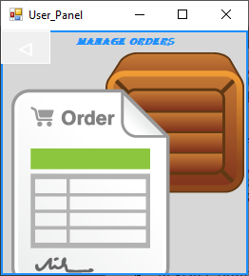

### Register_Admin.cs

using System;

using System.Collections.Generic;

using System.ComponentModel;

using System.Data;

using System.Drawing;

using System.Linq;

using System.Text;

using System.Threading.Tasks;

using System.Windows.Forms;

using System.Data.SqlClient;

using Microsoft.VisualBasic;

namespace SM_Management_System_DBMS

{

public partial class Register_Admin : Form

{

private int count = 0;

public Register_Admin()

{

InitializeComponent();

}

private void signup_admin_Load(object sender, EventArgs e)

{

string password = "0111";

inputbox:

string pass = Interaction.InputBox("Input Password", "Password Entered", "Password", 250, 250);

if (pass == password)

{

}

else if (pass != password)

{

MessageBox.Show("Incorrectpassword", "Unexpected Error", MessageBoxButtons.OK, MessageBoxIcon.Error);

goto inputbox;

}

}

public void add_admin()

{try

{

using (SqlConnection sqlcon = new SqlConnection(Starting_form.con))

{

sqlcon.Open();

SqlDataAdapter sqlda = new SqlDataAdapter("exec pro_insert_admins'" + textBox_name.Text + "','" + textBox_username.Text + "', '" + textBox_password.Text + "', '" + textBox_email.Text + "', '" + textBox_address.Text + "','" + dateTimePicker1.Text + "'", sqlcon);

DataTable dtbl = new DataTable();

sqlda.Fill(dtbl);

sqlcon.Close();

MessageBox.Show("record inserted successfully");

timer1.Start();

}

}

catch (Exception e)

{

MessageBox.Show("Already Inserted", "Error", MessageBoxButtons.OK, MessageBoxIcon.Error);

}

}

private void button_register_Click(object sender, EventArgs e)

{

if (textBox_password.ToString() == textBox_repass.ToString())

{

add_admin();

this.Hide();

Login login = new Login();

login.Show();

}

else if (textBox_password.ToString() != textBox_repass.ToString())

{

MessageBox.Show("Both password are not Same", "Same Password", MessageBoxButtons.OK, MessageBoxIcon.Information);

}

else

{

MessageBox.Show("Unexpected", "Error", MessageBoxButtons.OK, MessageBoxIcon.Error);

}

}

private void button_showadmin_Click(object sender, EventArgs e)

{

this.Hide();

Show_Admin show_admin = new SM_Management_System_DBMS.Show_Admin();

show_admin.Show();

}

private void timer1_Tick(object sender, EventArgs e)

{

count++;

if (count == 5)

{

this.Hide();

Login login = new SM_Management_System_DBMS.Login();

login.Show();

}

}

private void panel1_Paint(object sender, PaintEventArgs e)

{

}

private void button_back_Click(object sender, EventArgs e)

{

this.Hide();

Login login = new SM_Management_System_DBMS.Login();

login.Show();

}

private void textBox_name_KeyPress(object sender, KeyPressEventArgs e)

{

if (!char.IsLetter(e.KeyChar) && !char.IsControl(e.KeyChar) && !char.IsWhiteSpace(e.KeyChar))

e.Handled = true;

}

}

}

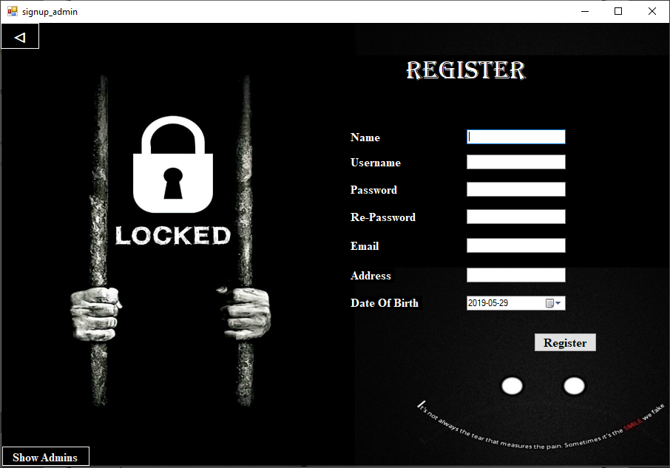

### Manage_Admins.cs

using System;

using System.Collections.Generic;

using System.ComponentModel;

using System.Data;

using System.Drawing;

using System.Linq;

using System.Text;

using System.Threading.Tasks;

using System.Windows.Forms;

using System.Data.SqlClient;

namespace SM_Management_System_DBMS

{

public partial class Manage_Admins : Form

{

public Manage_Admins()

{

InitializeComponent();

}

private void textBox_id_KeyPress(object sender, KeyPressEventArgs e)

{

if (!Char.IsDigit(e.KeyChar) && !char.IsControl(e.KeyChar))

{

e.Handled = true;

MessageBox.Show("Please Enter A Valid Id", "Invalid Format", MessageBoxButtons.OK, MessageBoxIcon.Information);

}

}

private void textBox_search_KeyPress(object sender, KeyPressEventArgs e)

{

}

private void textBox_name_KeyPress(object sender, KeyPressEventArgs e)

{

}

public void search_admins()

{

using (SqlConnection sqlcon = new SqlConnection(Starting_form.con))

{

sqlcon.Open();

SqlDataAdapter sqlda = new SqlDataAdapter("exec pro_search_admins'" + textBox_search.Text + "'", sqlcon);

DataTable dtbl = new DataTable();

sqlda.Fill(dtbl);

dataGridView1.DataSource = dtbl;

sqlcon.Close();

}

}

public void add_admins()

{

try

{

using (SqlConnection sqlcon = new SqlConnection(Starting_form.con))

{

sqlcon.Open();

SqlDataAdapter sqlda = new SqlDataAdapter("exec pro_insert_admins'" + textBox_name.Text + "','" + textBox_username.Text + "','" + textBox_password.Text + "','" + textBox_email.Text + "','" + textBox_address.Text + "','" + dateTimePicker1.Text + "'", sqlcon);

DataTable dtbl = new DataTable();

sqlda.Fill(dtbl);

dataGridView1.DataSource = dtbl;

sqlcon.Close();

}

}

catch (Exception e)

{

MessageBox.Show("Admin Already exists", "Error", MessageBoxButtons.OK, MessageBoxIcon.Error);

}

}

public void delete_admins()

{

using (SqlConnection sqlcon = new SqlConnection(Starting_form.con))

{

sqlcon.Open();

SqlDataAdapter sqlda = new SqlDataAdapter("exec pro_delete_admins'" + textBox_id.Text + "'", sqlcon);

DataTable dtbl = new DataTable();

sqlda.Fill(dtbl);

dataGridView1.DataSource = dtbl;

sqlcon.Close();

}

}

public void update_admins()

{

try

{

using (SqlConnection sqlcon = new SqlConnection(Starting_form.con))

{

sqlcon.Open();

SqlDataAdapter sqlda = new SqlDataAdapter("exec pro_update_admins'" + textBox_id.Text + "','" + textBox_name.Text + "','" + textBox_username.Text + "','" + textBox_password.Text + "','" + textBox_email.Text + "','" + textBox_address.Text + "','" + dateTimePicker1.Text + "'", sqlcon);

DataTable dtbl = new DataTable();

sqlda.Fill(dtbl);

dataGridView1.DataSource = dtbl;

sqlcon.Close();

}

}

catch (Exception e)

{

MessageBox.Show("Already Exist", "Error", MessageBoxButtons.OK, MessageBoxIcon.Error);

}

}

public void display_admins()

{

using (SqlConnection sqlcon = new SqlConnection(Starting_form.con))

{

sqlcon.Open();

SqlDataAdapter sqlda = new SqlDataAdapter("exec pro_show_admins", sqlcon);

DataTable dtbl = new DataTable();

sqlda.Fill(dtbl);

dataGridView1.DataSource = dtbl;

sqlcon.Close();

}

}

private void button_back_Click(object sender, EventArgs e)

{

this.Hide();

Admin_Panel admin_panel = new Admin_Panel();

admin_panel.Show();

}

private void textBox_search_KeyPress_1(object sender, KeyPressEventArgs e)

{

if (!char.IsLetter(e.KeyChar) && !char.IsControl(e.KeyChar) && !char.IsWhiteSpace(e.KeyChar))

e.Handled = true;

}

private void textBox_name_KeyPress_1(object sender, KeyPressEventArgs e)

{

if (!char.IsLetter(e.KeyChar) && !char.IsControl(e.KeyChar) && !char.IsWhiteSpace(e.KeyChar))

e.Handled = true;

}

private void button_add_Click(object sender, EventArgs e)

{

if (textBox_password.ToString() == textBox_repassword.ToString())

{

add_admins();

display_admins();

}

else if (textBox_password.ToString() != textBox_repassword.ToString())

{

MessageBox.Show("Both password are not Same", "Same Password", MessageBoxButtons.OK, MessageBoxIcon.Information);

}

else

{

MessageBox.Show("Unexpected", "Error", MessageBoxButtons.OK, MessageBoxIcon.Error);

}

}

private void button_delete_Click(object sender, EventArgs e)

{

delete_admins();

display_admins();

}

private void button_update_Click(object sender, EventArgs e)

{

if (textBox_password.ToString() == textBox_repassword.ToString())

{

update_admins();

display_admins();

}

else if (textBox_password.ToString() != textBox_repassword.ToString())

{

MessageBox.Show("Both password are not Same", "Same Password", MessageBoxButtons.OK, MessageBoxIcon.Information);

}

else

{

MessageBox.Show("Unexpected", "Error", MessageBoxButtons.OK, MessageBoxIcon.Error);

}

}

private void button_display_Click(object sender, EventArgs e)

{

display_admins();

}

private void textBox_search_TextChanged(object sender, EventArgs e)

{

search_admins();

}

private void Manage_Admins_Load(object sender, EventArgs e)

{

display_admins();

}

}

}

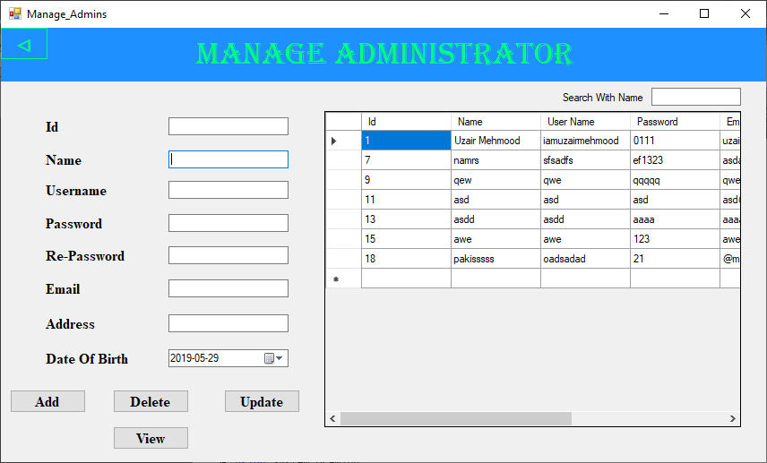

### Manage_Users.cs

using System;

using System.Collections.Generic;

using System.ComponentModel;

using System.Data;

using System.Drawing;

using System.Linq;

using System.Text;

using System.Threading.Tasks;

using System.Windows.Forms;

using System.Data.SqlClient;

namespace SM_Management_System_DBMS

{

public partial class Manage_User : Form

{

public Manage_User()

{

InitializeComponent();

}

private void Manage_User_Load(object sender, EventArgs e)

{

display_users();

}

private void textBox_search_TextChanged(object sender, EventArgs e)

{

search_users();

}

public void search_users()

{

using (SqlConnection sqlcon = new SqlConnection(Starting_form.con))

{

sqlcon.Open();

SqlDataAdapter sqlda = new SqlDataAdapter("exec pro_search_users'" + textBox_search.Text + "'", sqlcon);

DataTable dtbl = new DataTable();

sqlda.Fill(dtbl);

dataGridView1.DataSource = dtbl;

sqlcon.Close();

}

}

public void add_users()

{

try

{

using (SqlConnection sqlcon = new SqlConnection(Starting_form.con))

{

sqlcon.Open();

SqlDataAdapter sqlda = new SqlDataAdapter("exec pro_insert_users'" + textBox_name.Text + "','" + textBox_username.Text + "','"+textBox_password.Text+"','" + textBox_email + "','" + textBox_address.Text + "','" + dateTimePicker1.Text + "'", sqlcon);

DataTable dtbl = new DataTable();

sqlda.Fill(dtbl);

MessageBox.Show("User Registered Succesfully", "Registered", MessageBoxButtons.OK, MessageBoxIcon.Information);

dataGridView1.DataSource = dtbl;

sqlcon.Close();

}

}

catch (Exception e)

{

MessageBox.Show("Admin Already exists", "Error", MessageBoxButtons.OK, MessageBoxIcon.Error);

}

}

public void delete_users()

{

using (SqlConnection sqlcon = new SqlConnection(Starting_form.con))

{

sqlcon.Open();

SqlDataAdapter sqlda = new SqlDataAdapter("exec pro_delete_users'" + textBox_id.Text + "'", sqlcon);

DataTable dtbl = new DataTable();

sqlda.Fill(dtbl);

dataGridView1.DataSource = dtbl;

sqlcon.Close();

}

}

public void update_users()

{

try

{

using (SqlConnection sqlcon = new SqlConnection(Starting_form.con))

{

sqlcon.Open();

SqlDataAdapter sqlda = new SqlDataAdapter("exec pro_update_users'"+textBox_id.Text+"','" + textBox_name.Text + "','" + textBox_username.Text + "','" + textBox_password.Text + "','" + textBox_email + "','" + textBox_address.Text + "','" + dateTimePicker1.Text + "'", sqlcon);

DataTable dtbl = new DataTable();

sqlda.Fill(dtbl);

dataGridView1.DataSource = dtbl;

sqlcon.Close();

}

}

catch (Exception e)

{

MessageBox.Show("Already Exist", "Error", MessageBoxButtons.OK, MessageBoxIcon.Error);

}

}

public void display_users()

{

using (SqlConnection sqlcon = new SqlConnection(Starting_form.con))

{

sqlcon.Open();

SqlDataAdapter sqlda = new SqlDataAdapter("exec pro_show_users", sqlcon);

DataTable dtbl = new DataTable();

sqlda.Fill(dtbl);

dataGridView1.DataSource = dtbl;

sqlcon.Close();

}

}

private void button_add_Click(object sender, EventArgs e)

{

if (textBox_password.ToString() == textBox_repassword.ToString())

{

add_users();

display_users();

}

else if (textBox_password.ToString() != textBox_repassword.ToString())

{

MessageBox.Show("Both password are not Same");

}

}

private void button_delete_Click(object sender, EventArgs e)

{

delete_users();

display_users();

}

private void button_update_Click(object sender, EventArgs e)

{

if (textBox_password.ToString() == textBox_repassword.ToString())

{

update_users();

display_users();

}

else if (textBox_password.ToString() != textBox_repassword.ToString())

{

MessageBox.Show("Both password are not Same", "Same Password", MessageBoxButtons.OK, MessageBoxIcon.Information);

}

else

{

MessageBox.Show("Unexpected", "Error", MessageBoxButtons.OK, MessageBoxIcon.Error);

}

}

private void button_back_Click(object sender, EventArgs e)

{

this.Hide();

Admin_Panel admin_panel = new Admin_Panel();

admin_panel.Show();

}

private void button_display_Click(object sender, EventArgs e)

{

display_users();

}

private void textBox_id_TextChanged(object sender, EventArgs e)

{

}

private void textBox_id_KeyPress(object sender, KeyPressEventArgs e)

{

if (!Char.IsDigit(e.KeyChar) && !char.IsControl(e.KeyChar))

{

e.Handled = true;

MessageBox.Show("Please Enter A Valid Id", "Invalid Format", MessageBoxButtons.OK, MessageBoxIcon.Information);

}

}

private void textBox_name_KeyPress(object sender, KeyPressEventArgs e)

{

if (!char.IsLetter(e.KeyChar) && !char.IsControl(e.KeyChar) && !char.IsWhiteSpace(e.KeyChar))

e.Handled = true;

}

private void textBox_search_KeyPress(object sender, KeyPressEventArgs e)

{

if (!char.IsLetter(e.KeyChar) && !char.IsControl(e.KeyChar) && !char.IsWhiteSpace(e.KeyChar))

e.Handled = true;

}

}

}

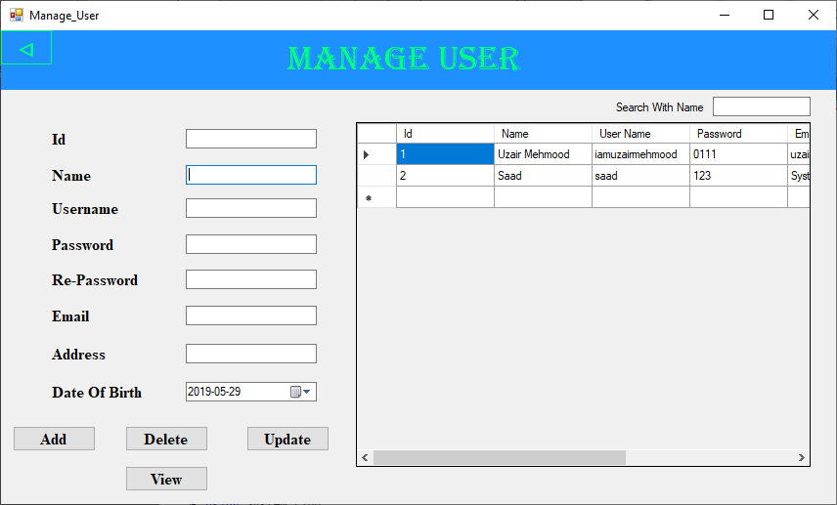

### Manage_Employees.cs

using System;

using System.Collections.Generic;

using System.ComponentModel;

using System.Data;

using System.Drawing;

using System.Linq;

using System.Text;

using System.Threading.Tasks;

using System.Windows.Forms;

using System.Data.SqlClient;

namespace SM_Management_System_DBMS

{

public partial class Manage_Employees : Form

{

public Manage_Employees()

{

InitializeComponent();

}

private void label9_Click(object sender, EventArgs e)

{

}

private void Manage_Employees_Load(object sender, EventArgs e)

{

comboBox_gender.DropDownStyle = ComboBoxStyle.DropDownList;

display_employees();

}

private void textBox_search_TextChanged(object sender, EventArgs e)

{

search_employees();

}

public void search_employees()

{

using (SqlConnection sqlcon = new SqlConnection(Starting_form.con))

{

sqlcon.Open();

SqlDataAdapter sqlda = new SqlDataAdapter("exec pro_search_employees'" + textBox_search.Text + "'", sqlcon);

DataTable dtbl = new DataTable();

sqlda.Fill(dtbl);

dataGridView1.DataSource = dtbl;

sqlcon.Close();

}

}

public void add_employees()

{

try

{

using (SqlConnection sqlcon = new SqlConnection(Starting_form.con))

{

sqlcon.Open();

SqlDataAdapter sqlda = new SqlDataAdapter("exec pro_insert_employees'" + textBox_name.Text + "','" + comboBox_gender.Text + "','"+textBox_email.Text+"','" + textBox_address.Text + "','" + textBox_phonenumber.Text + "','" + dateTimePicker1.Text + "','"+textBox_salary.Text+"'", sqlcon);

DataTable dtbl = new DataTable();

sqlda.Fill(dtbl);

dataGridView1.DataSource = dtbl;

sqlcon.Close();

}

}

catch (Exception e)

{

MessageBox.Show("Employee Already exists", "Error", MessageBoxButtons.OK, MessageBoxIcon.Error);

}

}

public void update_employees()

{

try

{

using (SqlConnection sqlcon = new SqlConnection(Starting_form.con))

{

sqlcon.Open();

SqlDataAdapter sqlda = new SqlDataAdapter("exec pro_update_employees'"+textBox_Id.Text+"','" + textBox_name.Text + "','" + comboBox_gender.Text + "','" + textBox_email.Text + "','" + textBox_address.Text + "','" + textBox_phonenumber.Text + "','" + dateTimePicker1.Text + "','" + textBox_salary.Text + "'", sqlcon);

DataTable dtbl = new DataTable();

sqlda.Fill(dtbl);

dataGridView1.DataSource = dtbl;

sqlcon.Close();

}

}

catch (Exception e)

{

MessageBox.Show("Already Exist", "Error", MessageBoxButtons.OK, MessageBoxIcon.Error);

}

}

public void delete_employees()

{

using (SqlConnection sqlcon = new SqlConnection(Starting_form.con))

{

sqlcon.Open();

SqlDataAdapter sqlda = new SqlDataAdapter("exec pro_delete_employees'" + textBox_Id.Text + "'", sqlcon);

DataTable dtbl = new DataTable();

sqlda.Fill(dtbl);

dataGridView1.DataSource = dtbl;

sqlcon.Close();

}

}

public void display_employees()

{

using (SqlConnection sqlcon = new SqlConnection(Starting_form.con))

{

sqlcon.Open();

SqlDataAdapter sqlda = new SqlDataAdapter("exec pro_show_employees", sqlcon);

DataTable dtbl = new DataTable();

sqlda.Fill(dtbl);

dataGridView1.DataSource = dtbl;

sqlcon.Close();

}

}

private void button_add_Click(object sender, EventArgs e)

{

add_employees();

display_employees();

}

private void dataGridView1_CellContentClick(object sender, DataGridViewCellEventArgs e)

{

display_employees();

}

private void button_delete_Click(object sender, EventArgs e)

{

delete_employees();

display_employees();

}

private void button_update_Click(object sender, EventArgs e)

{

update_employees();

display_employees();

}

private void button_back_Click(object sender, EventArgs e)

{

this.Hide();

Admin_Panel admin_panel = new Admin_Panel();

admin_panel.Show();

}

private void button_display_Click(object sender, EventArgs e)

{

display_employees();

}

private void textBox_Id_KeyPress(object sender, KeyPressEventArgs e)

{

if (!Char.IsDigit(e.KeyChar) && !char.IsControl(e.KeyChar))

{

e.Handled = true;

MessageBox.Show("Please Enter A Valid Id", "Invalid Format", MessageBoxButtons.OK, MessageBoxIcon.Information);

}

}

private void textBox_salary_KeyPress(object sender, KeyPressEventArgs e)

{

if (!char.IsDigit(e.KeyChar) && !char.IsControl(e.KeyChar))

e.Handled = true;

}

private void textBox_search_KeyPress(object sender, KeyPressEventArgs e)

{

if (!char.IsLetter(e.KeyChar) && !char.IsControl(e.KeyChar) && !char.IsWhiteSpace(e.KeyChar))

e.Handled = true;

}

private void textBox_name_TextChanged(object sender, EventArgs e)

{

}

private void textBox_name_KeyPress(object sender, KeyPressEventArgs e)

{

if (!char.IsLetter(e.KeyChar) && !char.IsControl(e.KeyChar) && !char.IsWhiteSpace(e.KeyChar))

e.Handled = true;

}

private void comboBox_gender_KeyPress(object sender, KeyPressEventArgs e)

{

if (!char.IsLetter(e.KeyChar) && !char.IsControl(e.KeyChar) && !char.IsWhiteSpace(e.KeyChar))

e.Handled = true;

}

private void textBox_phonenumber_KeyPress(object sender, KeyPressEventArgs e)

{

if (!Char.IsDigit(e.KeyChar) && !char.IsControl(e.KeyChar))

e.Handled = true;

}

}

}

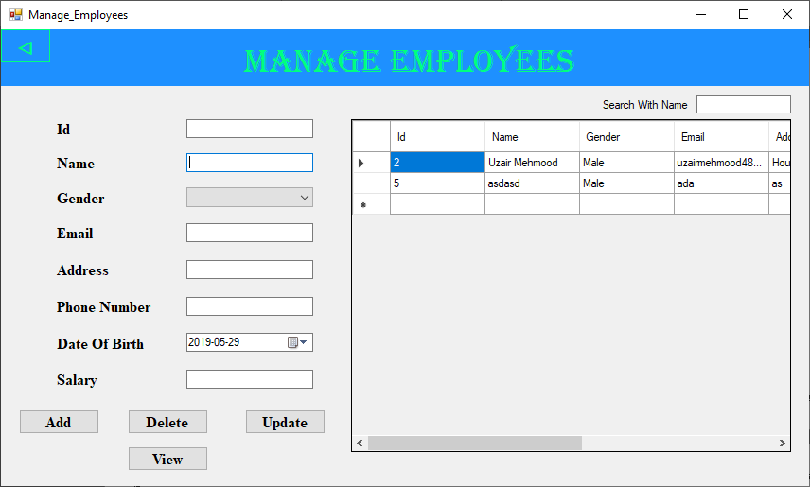

### 

### Manage_Suppliers.cs

using System;

using System.Collections.Generic;

using System.ComponentModel;

using System.Data;

using System.Drawing;

using System.Linq;

using System.Text;

using System.Threading.Tasks;

using System.Windows.Forms;

using System.Data.SqlClient;

namespace SM_Management_System_DBMS

{

public partial class Manage_Supplier : Form

{

public Manage_Supplier()

{

InitializeComponent();

}

private void textBox_search_TextChanged(object sender, EventArgs e)

{

search_suppliers();

}

public void search_suppliers()

{

using (SqlConnection sqlcon = new SqlConnection(Starting_form.con))

{

sqlcon.Open();

SqlDataAdapter sqlda = new SqlDataAdapter("exec pro_search_suppliers'" + textBox_search.Text + "'", sqlcon);

DataTable dtbl = new DataTable();

sqlda.Fill(dtbl);

dataGridView1.DataSource = dtbl;

sqlcon.Close();

}

}

public void add_suppliers()

{

try

{

using (SqlConnection sqlcon = new SqlConnection(Starting_form.con))

{

sqlcon.Open();

SqlDataAdapter sqlda = new SqlDataAdapter("exec pro_insert_suppliers'" + textBox_name.Text + "','" + textBox_email.Text + "','" + textBox_address.Text + "','" + textBox_phonenumber.Text + "','" + dateTimePicker1.Text + "'", sqlcon);

DataTable dtbl = new DataTable();

sqlda.Fill(dtbl);

dataGridView1.DataSource = dtbl;

sqlcon.Close();

}

}

catch (Exception e)

{

MessageBox.Show("Admin Already exists", "Error", MessageBoxButtons.OK, MessageBoxIcon.Error);

}

}

public void delete_suppliers()

{

using (SqlConnection sqlcon = new SqlConnection(Starting_form.con))

{

sqlcon.Open();

SqlDataAdapter sqlda = new SqlDataAdapter("exec pro_delete_suppliers'"+textBox_id.Text+"'", sqlcon);

DataTable dtbl = new DataTable();

sqlda.Fill(dtbl);

dataGridView1.DataSource = dtbl;

sqlcon.Close();

}

}

public void update_suppliers()

{

try

{

using (SqlConnection sqlcon = new SqlConnection(Starting_form.con))

{

sqlcon.Open();

SqlDataAdapter sqlda = new SqlDataAdapter("exec pro_update_suppliers'" + textBox_id.Text + "','" + textBox_name.Text + "','" + textBox_email.Text + "','" + textBox_address.Text + "','" + textBox_phonenumber.Text + "','" + dateTimePicker1.Text + "'", sqlcon);

DataTable dtbl = new DataTable();

sqlda.Fill(dtbl);

dataGridView1.DataSource = dtbl;

sqlcon.Close();

}

}

catch (Exception e)

{

MessageBox.Show("Already Exist", "Error", MessageBoxButtons.OK, MessageBoxIcon.Error);

}

}

public void display_suppliers()

{

using (SqlConnection sqlcon = new SqlConnection(Starting_form.con))

{

sqlcon.Open();

SqlDataAdapter sqlda = new SqlDataAdapter("exec pro_show_suppliers", sqlcon);

DataTable dtbl = new DataTable();

sqlda.Fill(dtbl);

dataGridView1.DataSource = dtbl;

sqlcon.Close();

} }

private void Manage_Supplier_Load(object sender, EventArgs e)

{

display_suppliers();

}

private void dataGridView1_CellContentClick(object sender, DataGridViewCellEventArgs e)

{

display_suppliers();

}

private void button_add_Click(object sender, EventArgs e)

{

add_suppliers();

display_suppliers();

}

private void button_delete_Click(object sender, EventArgs e)

{

delete_suppliers();

display_suppliers();

}

private void button_update_Click(object sender, EventArgs e)

{

update_suppliers();

display_suppliers();

}

private void button_back_Click(object sender, EventArgs e)

{

this.Hide();

Admin_Panel admin_panel = new Admin_Panel();

admin_panel.Show();

}

private void button_display_Click(object sender, EventArgs e)

{

display_suppliers();

}

private void textBox_id_KeyPress(object sender, KeyPressEventArgs e)

{

if (!Char.IsDigit(e.KeyChar) && !char.IsControl(e.KeyChar))

{

e.Handled = true;

MessageBox.Show("Please Enter A Valid Id", "Invalid Format", MessageBoxButtons.OK, MessageBoxIcon.Information);

}

}

private void textBox_name_KeyPress(object sender, KeyPressEventArgs e)

{

if (!char.IsLetter(e.KeyChar) && !char.IsControl(e.KeyChar) && !char.IsWhiteSpace(e.KeyChar))

e.Handled = true;

}

private void textBox_search_KeyPress(object sender, KeyPressEventArgs e)

{

if (!char.IsLetter(e.KeyChar) && !char.IsControl(e.KeyChar) && !char.IsWhiteSpace(e.KeyChar))

e.Handled = true;

}

private void textBox_phonenumber_KeyPress(object sender, KeyPressEventArgs e)

{

if (!Char.IsDigit(e.KeyChar) && !char.IsControl(e.KeyChar))

e.Handled = true;

} }}

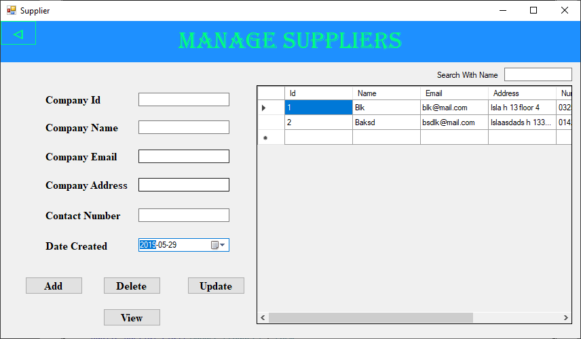

### Manage_Products.cs

using System;

using System.Collections.Generic;

using System.ComponentModel;

using System.Data;

using System.Drawing;

using System.Linq;

using System.Text;

using System.Threading.Tasks;

using System.Windows.Forms;

using System.Data.SqlClient;

namespace SM_Management_System_DBMS

{

public partial class Manage_Products : Form

{

public Manage_Products()

{

InitializeComponent();

}

private void label8_Click(object sender, EventArgs e)

{

}

private void Manage_Products_Load(object sender, EventArgs e)

{

comboBox_quantity.DropDownStyle = ComboBoxStyle.DropDownList;

comboBox_weight.DropDownStyle = ComboBoxStyle.DropDownList;

comboBox_supplierid.DropDownStyle = ComboBoxStyle.DropDownList;

display_products();

fill_combo();

textBox_sname.ReadOnly = true;

for (int i = 1; i <= 999; i++)

{

string[] numbers = { i.ToString() };

comboBox_weight.Items.AddRange(numbers);

comboBox_price.Items.AddRange(numbers);

comboBox_quantity.Items.AddRange(numbers);

}

}

private void textBox_search_TextChanged(object sender, EventArgs e)

{

search_products();

}

public void search_products()

{

using (SqlConnection sqlcon = new SqlConnection(Starting_form.con))

{

sqlcon.Open();

SqlDataAdapter sqlda = new SqlDataAdapter("exec pro_search_products'" + textBox_search.Text + "'", sqlcon);

DataTable dtbl = new DataTable();

sqlda.Fill(dtbl);

dataGridView1.DataSource = dtbl;

sqlcon.Close();

}

}

public void add_products()

{

try

{

using (SqlConnection sqlcon = new SqlConnection(Starting_form.con))

{

sqlcon.Open();

SqlDataAdapter sqlda = new SqlDataAdapter("exec pro_insert_products'" + textBox_name.Text + "','"+comboBox_quantity.Text+"','"+comboBox_price.Text+"','"+comboBox_weight.Text+"','"+comboBox_supplierid.Text+"'", sqlcon);

DataTable dtbl = new DataTable();

sqlda.Fill(dtbl);

dataGridView1.DataSource = dtbl;

sqlcon.Close();

}

}

catch (Exception e)

{

MessageBox.Show("Product Already exists", "Error", MessageBoxButtons.OK, MessageBoxIcon.Error);

}

}

public void update_products()

{

try

{

using (SqlConnection sqlcon = new SqlConnection(Starting_form.con))

{

sqlcon.Open();

SqlDataAdapter sqlda = new SqlDataAdapter("exec pro_update_products'"+textBox_Id.Text+"','" + textBox_name.Text + "','" + comboBox_quantity.Text + "','" + comboBox_price.Text + "','" + comboBox_weight.Text + "','" + comboBox_supplierid.Text + "'", sqlcon);

DataTable dtbl = new DataTable();

sqlda.Fill(dtbl);

dataGridView1.DataSource = dtbl;

sqlcon.Close();

}

}

catch (Exception e)

{

MessageBox.Show("Already Exist", "Error", MessageBoxButtons.OK, MessageBoxIcon.Error);

}

}

public void delete_products()

{

using (SqlConnection sqlcon = new SqlConnection(Starting_form.con))

{

sqlcon.Open();

SqlDataAdapter sqlda = new SqlDataAdapter("exec pro_delete_products'" + textBox_Id.Text + "'", sqlcon);

DataTable dtbl = new DataTable();

sqlda.Fill(dtbl);

dataGridView1.DataSource = dtbl;

sqlcon.Close();

}

}

public void display_products()

{

using (SqlConnection sqlcon = new SqlConnection(Starting_form.con))

{

sqlcon.Open();

SqlDataAdapter sqlda = new SqlDataAdapter("exec pro_show_products", sqlcon);

DataTable dtbl = new DataTable();

sqlda.Fill(dtbl);

dataGridView1.DataSource = dtbl;

sqlcon.Close();

}

}

private void button_add_Click(object sender, EventArgs e)

{

add_products();

display_products();

}

private void dataGridView1_CellContentClick(object sender, DataGridViewCellEventArgs e)

{

display_products();

}

private void button_delete_Click(object sender, EventArgs e)

{

delete_products();

display_products();

}

private void button_update_Click(object sender, EventArgs e)

{

update_products();

display_products();

}

private void button_back_Click(object sender, EventArgs e)

{

this.Hide();

Admin_Panel admin_panel = new Admin_Panel();

admin_panel.Show();

}

private void button_display_Click(object sender, EventArgs e)

{

display_products();

}

private void textBox_Id_KeyPress(object sender, KeyPressEventArgs e)

{

if (!Char.IsDigit(e.KeyChar) && !char.IsControl(e.KeyChar) )

{

e.Handled = true;

MessageBox.Show("Please Enter A Valid Id", "Invalid Format", MessageBoxButtons.OK, MessageBoxIcon.Information);

}

}

private void comboBox_quantity_KeyPress(object sender, KeyPressEventArgs e)

{

if (!char.IsDigit(e.KeyChar) && !char.IsControl(e.KeyChar) )

e.Handled = true;

}

private void comboBox_price_KeyPress(object sender, KeyPressEventArgs e)

{

if (!char.IsDigit(e.KeyChar) && !char.IsControl(e.KeyChar))

e.Handled = true;

}

private void comboBox_weight_KeyPress(object sender, KeyPressEventArgs e)

{

if (!char.IsDigit(e.KeyChar) && !char.IsControl(e.KeyChar))

e.Handled = true;

}

private void comboBox_supplierid_KeyPress(object sender, KeyPressEventArgs e)

{

if (!char.IsDigit(e.KeyChar) && !char.IsControl(e.KeyChar))

e.Handled = true;

}

private void textBox_name_KeyPress(object sender, KeyPressEventArgs e)

{

if (!char.IsLetter(e.KeyChar) && !char.IsControl(e.KeyChar) && !char.IsWhiteSpace(e.KeyChar))

e.Handled = true;

}

private void textBox_search_KeyPress(object sender, KeyPressEventArgs e)

{

if (!char.IsLetter(e.KeyChar) && !char.IsControl(e.KeyChar) && !char.IsWhiteSpace(e.KeyChar))

e.Handled = true;

}

public void fill_combo()

{

try

{

using (SqlConnection sqlcon = new SqlConnection(Starting_form.con))

{

sqlcon.Open();

SqlDataAdapter sqlda = new SqlDataAdapter("select * from suppliers order by Id ASC", sqlcon);

DataTable dt1 = new DataTable();

sqlda.Fill(dt1);

//dataGridView1.DataSource = dt;

foreach (DataRow dr in dt1.Rows)

{

comboBox_supplierid.Items.Add(dr["Id"].ToString());

}

sqlcon.Close();

}

}

catch (Exception e)

{

MessageBox.Show("Failed to Fill Supplier's Data", "Error", MessageBoxButtons.OK, MessageBoxIcon.Error);

}

}

public void fill_textbox()

{

using (SqlConnection sqlcon = new SqlConnection(Starting_form.con))

{

sqlcon.Open();

SqlDataAdapter sqlda = new SqlDataAdapter("select * from suppliers where Id = '"+comboBox_supplierid.Text+"'", sqlcon);

DataTable dt2 = new DataTable();

sqlda.Fill(dt2);

//dataGridView1.DataSource = dt;

foreach (DataRow dr in dt2.Rows)

{

// comboBox_supplierid.Items.Add(dr["Id"].ToString());

textBox_sname.Text = dr["Name"].ToString();

}

sqlcon.Close();

}

}

private void comboBox_supplierid_Enter(object sender, EventArgs e)

{

fill_textbox();

}

private void comboBox_supplierid_MouseLeave(object sender, EventArgs e)

{

fill_textbox();

}

private void comboBox_supplierid_KeyDown(object sender, KeyEventArgs e)

{

fill_textbox();

}

private void comboBox_supplierid_PreviewKeyDown(object sender, PreviewKeyDownEventArgs e)

{

fill_textbox();

}

private void comboBox_supplierid_KeyUp(object sender, KeyEventArgs e)

{

fill_textbox();

}

private void comboBox_supplierid_MouseHover(object sender, EventArgs e)

{

fill_textbox();

}

private void comboBox_supplierid_MouseMove(object sender, MouseEventArgs e)

{

fill_textbox();

}

}

}

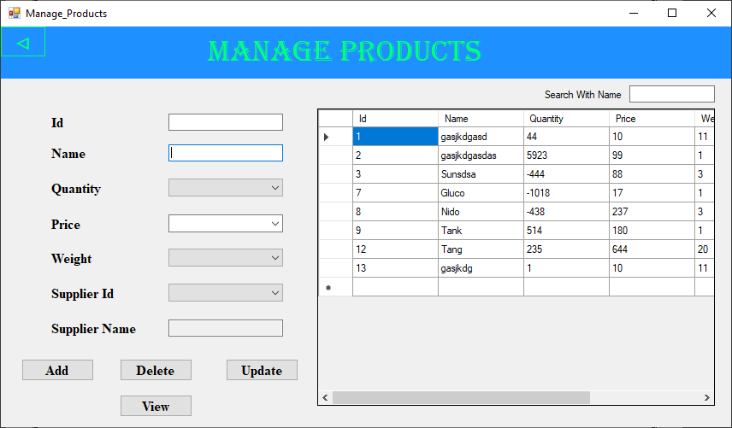

### 

### Manage_Drivers.cs

using System;

using System.Collections.Generic;

using System.ComponentModel;

using System.Data;

using System.Drawing;

using System.Linq;

using System.Text;

using System.Threading.Tasks;

using System.Windows.Forms;

using System.Data.SqlClient;

namespace SM_Management_System_DBMS

{

public partial class Manage_Drivers : Form

{

public Manage_Drivers()

{

InitializeComponent();

}

private void label123_Click(object sender, EventArgs e)

{

}

private void label1_Click(object sender, EventArgs e)

{

}

private void label2_Click(object sender, EventArgs e)

{

}

private void textBox3_TextChanged(object sender, EventArgs e)

{

}

private void label3_Click(object sender, EventArgs e)

{

}

private void textBox_search_TextChanged(object sender, EventArgs e)

{

search_driver();

}

private void Manage_Drivers_Load(object sender, EventArgs e)

{

comboBox_gender.DropDownStyle = ComboBoxStyle.DropDownList;

display_drivers();

}

public void search_driver()

{

using (SqlConnection sqlcon = new SqlConnection(Starting_form.con))

{

sqlcon.Open();

SqlDataAdapter sqlda = new SqlDataAdapter("exec pro_search_drivers'" + textBox_search.Text + "'", sqlcon);

DataTable dtbl = new DataTable();

sqlda.Fill(dtbl);

dataGridView1.DataSource = dtbl;

sqlcon.Close();

}

}

public void add_drivers()

{try

{

using (SqlConnection sqlcon = new SqlConnection(Starting_form.con))

{

sqlcon.Open();

SqlDataAdapter sqlda = new SqlDataAdapter("exec pro_insert_drivers'"+textBox_name.Text+"','"+comboBox_gender.Text+"','"+textBox_address.Text+"','"+textBox_phonenumber.Text+"','"+dateTimePicker1.Text+"'", sqlcon);

DataTable dtbl = new DataTable();

sqlda.Fill(dtbl);

dataGridView1.DataSource = dtbl;

sqlcon.Close();

}

}

catch (Exception e)

{

MessageBox.Show("Admin Already exists", "Error", MessageBoxButtons.OK, MessageBoxIcon.Error);

}

}

public void update_drivers()

{

try

{

using (SqlConnection sqlcon = new SqlConnection(Starting_form.con))

{

sqlcon.Open();

SqlDataAdapter sqlda = new SqlDataAdapter("exec pro_update_drivers '"+textBox_Id.Text+"','" + textBox_name.Text + "','" + comboBox_gender.Text + "','" + textBox_address.Text + "','" + textBox_phonenumber.Text + "','" + dateTimePicker1.Text + "'", sqlcon);

DataTable dtbl = new DataTable();

sqlda.Fill(dtbl);

dataGridView1.DataSource = dtbl;

sqlcon.Close();

}

}

catch (Exception e)

{

MessageBox.Show("Already Exist", "Error", MessageBoxButtons.OK, MessageBoxIcon.Error);

}

}

public void delete_drivers()

{

using (SqlConnection sqlcon = new SqlConnection(Starting_form.con))

{

sqlcon.Open();

SqlDataAdapter sqlda = new SqlDataAdapter("exec pro_delete_drivers'" + textBox_Id.Text + "'", sqlcon);

DataTable dtbl = new DataTable();

sqlda.Fill(dtbl);

dataGridView1.DataSource = dtbl;

sqlcon.Close();

}

}

public void display_drivers()

{

using (SqlConnection sqlcon = new SqlConnection(Starting_form.con))

{

sqlcon.Open();

SqlDataAdapter sqlda = new SqlDataAdapter("exec pro_show_drivers", sqlcon);

DataTable dtbl = new DataTable();

sqlda.Fill(dtbl);

dataGridView1.DataSource = dtbl;

sqlcon.Close();

}

}

private void dataGridView1_CellContentClick(object sender, DataGridViewCellEventArgs e)

{

display_drivers();

}

private void button_add_Click(object sender, EventArgs e)

{

add_drivers();

display_drivers();

}

private void button_delete_Click(object sender, EventArgs e)

{

delete_drivers();

display_drivers();

}

private void button_update_Click(object sender, EventArgs e)

{

update_drivers();

display_drivers();

}

private void button_back_Click(object sender, EventArgs e)

{

this.Hide();

Admin_Panel admin_panel = new Admin_Panel();

admin_panel.Show();

}

private void button_display_Click(object sender, EventArgs e)

{

display_drivers();

}

private void textBox_Id_TextChanged(object sender, EventArgs e)

{

}

private void textBox_Id_KeyPress(object sender, KeyPressEventArgs e)

{

if (!Char.IsDigit(e.KeyChar) && !char.IsControl(e.KeyChar))

{

e.Handled = true;

MessageBox.Show("Please Enter A Valid Id", "Invalid Format", MessageBoxButtons.OK, MessageBoxIcon.Information);

}

}

private void textBox_name_KeyPress(object sender, KeyPressEventArgs e)

{

if (!char.IsLetter(e.KeyChar) && !char.IsControl(e.KeyChar) && !char.IsWhiteSpace(e.KeyChar))

e.Handled = true;

}

private void textBox_search_KeyPress(object sender, KeyPressEventArgs e)

{

if (!char.IsLetter(e.KeyChar) && !char.IsControl(e.KeyChar) && !char.IsWhiteSpace(e.KeyChar))

e.Handled = true;

}

private void comboBox_gender_KeyPress(object sender, KeyPressEventArgs e)

{

if (!char.IsLetter(e.KeyChar) && !char.IsControl(e.KeyChar) && !char.IsWhiteSpace(e.KeyChar))

e.Handled = true;

}

private void dateTimePicker1_ValueChanged(object sender, EventArgs e)

{

}

private void textBox_phonenumber_KeyPress(object sender, KeyPressEventArgs e)

{

if (!Char.IsDigit(e.KeyChar) && !char.IsControl(e.KeyChar))

{

e.Handled = true;

}

}

}

}

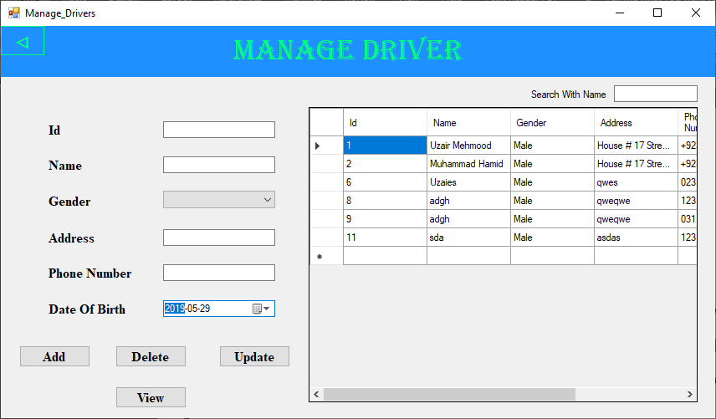

### Manage_Vehicle.cs

using System;

using System.Collections.Generic;

using System.ComponentModel;

using System.Data;

using System.Drawing;

using System.Linq;

using System.Text;

using System.Threading.Tasks;

using System.Windows.Forms;

using System.Data.SqlClient;

namespace SM_Management_System_DBMS

{

public partial class Manage_Vehicle : Form

{

public Manage_Vehicle()

{

InitializeComponent();

}

private void Manage_Vehicle_Load(object sender, EventArgs e)

{

display_vehicles();

comboBox_maxload.DropDownStyle = ComboBoxStyle.DropDownList;

for (int i = 1; i <= 1000; i++)

{

string[] numbers = { i.ToString() };

comboBox_maxload.Items.AddRange(numbers);

}

}

private void textBox_search_TextChanged(object sender, EventArgs e)

{

search_vehicles();

}

public void search_vehicles()

{

using (SqlConnection sqlcon = new SqlConnection(Starting_form.con))

{

sqlcon.Open();

SqlDataAdapter sqlda = new SqlDataAdapter("exec pro_search_vehicles'" + textBox_search.Text + "'", sqlcon);

DataTable dtbl = new DataTable();

sqlda.Fill(dtbl);

dataGridView1.DataSource = dtbl;

sqlcon.Close();

}

}

public void add_vehicles()

{

try {

using (SqlConnection sqlcon = new SqlConnection(Starting_form.con))

{

sqlcon.Open();

SqlDataAdapter sqlda = new SqlDataAdapter("exec pro_insert_vehicles '"+textBox_name.Text+"','"+textBox_vehiclenumber.Text+"','"+textBox_vehicalcompany.Text+"','"+comboBox_maxload.Text+"','"+dateTimePicker1.Text+"'",sqlcon);

DataTable dtbl = new DataTable();

sqlda.Fill(dtbl);

dataGridView1.DataSource = dtbl;

sqlcon.Close();

}

}

catch (Exception e)

{

MessageBox.Show("Vehicle Already exists", "Error", MessageBoxButtons.OK, MessageBoxIcon.Error);

}

}

public void update_vehicles()

{

try

{

using (SqlConnection sqlcon = new SqlConnection(Starting_form.con))

{

sqlcon.Open();

SqlDataAdapter sqlda = new SqlDataAdapter("exec pro_update_vehicles'"+textBox_id.Text+"','" + textBox_name.Text + "','" + textBox_vehiclenumber.Text + "','"+textBox_vehicalcompany.Text+"','" + comboBox_maxload.Text + "','" + dateTimePicker1.Text + "'", sqlcon);

DataTable dtbl = new DataTable();

sqlda.Fill(dtbl);

dataGridView1.DataSource = dtbl;

sqlcon.Close();

}

}

catch (Exception e)

{

MessageBox.Show("Already Exist", "Error", MessageBoxButtons.OK, MessageBoxIcon.Error);

}

}

public void delete_vehicles()

{

using (SqlConnection sqlcon = new SqlConnection(Starting_form.con))

{

sqlcon.Open();

SqlDataAdapter sqlda = new SqlDataAdapter("exec pro_delete_vehicles'"+textBox_id.Text+"'", sqlcon);

DataTable dtbl = new DataTable();

sqlda.Fill(dtbl);

dataGridView1.DataSource = dtbl;

sqlcon.Close();

}

}

public void display_vehicles()

{

using (SqlConnection sqlcon = new SqlConnection(Starting_form.con))

{

sqlcon.Open();

SqlDataAdapter sqlda = new SqlDataAdapter("exec pro_show_vehicles", sqlcon);

DataTable dtbl = new DataTable();

sqlda.Fill(dtbl);

dataGridView1.DataSource = dtbl;

sqlcon.Close();

}

}

private void button_back_Click(object sender, EventArgs e)

{

this.Hide();

Admin_Panel admin_panel = new Admin_Panel();

admin_panel.Show();

}

private void button_display_Click(object sender, EventArgs e)

{

display_vehicles();

}

private void textBox_id_KeyPress(object sender, KeyPressEventArgs e)

{

if (!Char.IsDigit(e.KeyChar) && !char.IsControl(e.KeyChar))

{

e.Handled = true;

MessageBox.Show("Please Enter A Valid Id", "Invalid Format", MessageBoxButtons.OK, MessageBoxIcon.Information);

}

}

private void textBox_search_KeyPress(object sender, KeyPressEventArgs e)

{

if (!char.IsLetter(e.KeyChar) && !char.IsControl(e.KeyChar) && !char.IsWhiteSpace(e.KeyChar))

e.Handled = true;

}

private void textBox_vehicalcompany_KeyPress(object sender, KeyPressEventArgs e)

{

if (!char.IsLetter(e.KeyChar) && !char.IsControl(e.KeyChar) && !char.IsWhiteSpace(e.KeyChar))

e.Handled = true;

}

private void comboBox_maxload_KeyPress(object sender, KeyPressEventArgs e)

{

if (!Char.IsDigit(e.KeyChar) && !char.IsControl(e.KeyChar))

e.Handled = true;

}

private void button_update_Click(object sender, EventArgs e)

{

update_vehicles();

display_vehicles();

}

private void button_delete_Click(object sender, EventArgs e)

{

delete_vehicles();

display_vehicles();

}

private void button_add_Click(object sender, EventArgs e)

{

add_vehicles();

display_vehicles();

}

}

}

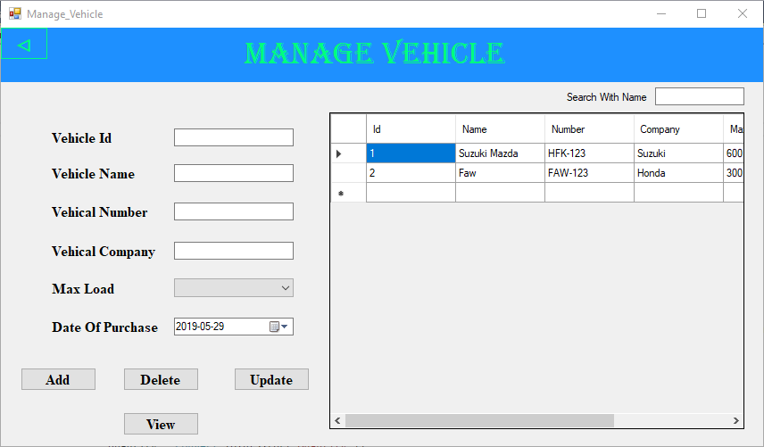

### Show_Admins.cs

using System;

using System.Collections.Generic;

using System.ComponentModel;

using System.Data;

using System.Drawing;

using System.Linq;

using System.Text;

using System.Threading.Tasks;

using System.Windows.Forms;

using System.Data.SqlClient;

namespace SM_Management_System_DBMS

{

public partial class Show_Admin : Form

{

public Show_Admin()

{

InitializeComponent();

}

private void panel1_Paint(object sender, PaintEventArgs e)

{

}

public void Display_Admin()

{

using (SqlConnection sqlcon = new SqlConnection(Starting_form.con))

{

sqlcon.Open();

SqlDataAdapter sqlda = new SqlDataAdapter("exec pro_show_admins", sqlcon);

DataTable dtbl = new DataTable();

sqlda.Fill(dtbl);

dataGridView1.DataSource = dtbl;

sqlcon.Close();

}

}

private void Show_Admin_Load(object sender, EventArgs e)

{

}

private void button_back_Click(object sender, EventArgs e)

{

this.Hide();

Register_Admin register_admin = new SM_Management_System_DBMS.Register_Admin();

register_admin.Show();

}

private void dataGridView1_CellContentClick(object sender, DataGridViewCellEventArgs e)

{

}

public void search_admins()

{

using (SqlConnection sqlcon = new SqlConnection(Starting_form.con))

{

sqlcon.Open();

SqlDataAdapter sqlda = new SqlDataAdapter("exec pro_search_admins'" + textBox_search.Text + "'", sqlcon);

DataTable dtbl = new DataTable();

sqlda.Fill(dtbl);

dataGridView1.DataSource = dtbl;

sqlcon.Close();

}

}

private void textBox_search_TextChanged(object sender, EventArgs e)

{

search_admins();

}

}

}

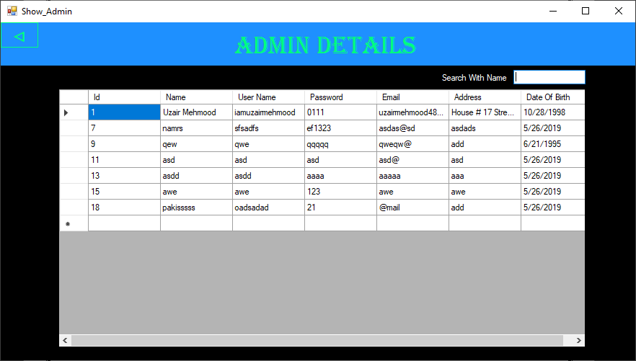

### Orders.cs

using System;

using System.Collections.Generic;

using System.ComponentModel;

using System.Data;

using System.Drawing;

using System.Linq;

using System.Text;

using System.Threading.Tasks;

using System.Windows.Forms;

using System.Data.SqlClient;

using System.IO;

namespace SM_Management_System_DBMS

{

public partial class Order : Form

{

static public int price, quantity, totalprice = 0, weight,i=1,totalweight=0;

static public string name;

public Order()

{

InitializeComponent();

}

private void label1_Click(object sender, EventArgs e)

{

}

private void comboBox1_SelectedIndexChanged(object sender, EventArgs e)

{

}

private void label123_Click(object sender, EventArgs e)

{

}

private void label3_Click(object sender, EventArgs e)

{

}

private void Order_Load(object sender, EventArgs e)

{

comboBox_quantity.DropDownStyle = ComboBoxStyle.DropDownList;

comboBox_id.DropDownStyle = ComboBoxStyle.DropDownList;

textBox_name.ReadOnly = true;

fill_combo();

for (int i = 1; i <= 50; i++)

{

string[] numbers = { i.ToString() };

comboBox_quantity.Items.AddRange(numbers);

}

}

private void button_delete_Click(object sender, EventArgs e)

{

delete();

}

private void label6_Click(object sender, EventArgs e)

{

}

public void fill_combo()

{

try

{

using (SqlConnection sqlcon = new SqlConnection(Starting_form.con))

{

sqlcon.Open();

SqlDataAdapter sqlda = new SqlDataAdapter("select * from products order by Id ASC", sqlcon);

DataTable dt1 = new DataTable();

sqlda.Fill(dt1);

//dataGridView1.DataSource = dt;

foreach (DataRow dr in dt1.Rows)

{

comboBox_id.Items.Add(dr["Id"].ToString());

}

sqlcon.Close();

}

}

catch (Exception e)

{

MessageBox.Show("Display Supplier Id Failed", "Error", MessageBoxButtons.OK, MessageBoxIcon.Error);

}

}

public void fill_textbox()

{

using (SqlConnection sqlcon = new SqlConnection(Starting_form.con))

{

sqlcon.Open();

SqlDataAdapter sqlda = new SqlDataAdapter("select * from products where Id = '" + comboBox_id.Text + "'", sqlcon);

DataTable dt2 = new DataTable();

sqlda.Fill(dt2);

//dataGridView1.DataSource = dt;

foreach (DataRow dr in dt2.Rows)

{

// comboBox_supplierid.Items.Add(dr["Id"].ToString());

textBox_name.Text = dr["Name"].ToString();

}

sqlcon.Close();

}

}

private void comboBox_id_KeyDown(object sender, KeyEventArgs e)

{

fill_textbox();

}

private void comboBox_id_KeyPress(object sender, KeyPressEventArgs e)

{

if (!Char.IsDigit(e.KeyChar) && !char.IsControl(e.KeyChar))

{

e.Handled = true;

}

fill_textbox();

}

private void comboBox_id_KeyUp(object sender, KeyEventArgs e)

{

fill_textbox();

}

private void comboBox_id_PreviewKeyDown(object sender, PreviewKeyDownEventArgs e)

{

fill_textbox();

}

private void comboBox_quantity_KeyPress(object sender, KeyPressEventArgs e)

{

if (!Char.IsDigit(e.KeyChar) && !char.IsControl(e.KeyChar))

{

e.Handled = true;

}

fill_textbox();

}

private void comboBox_id_MouseEnter(object sender, EventArgs e)

{

fill_textbox();

}

private void comboBox_id_MouseDown(object sender, MouseEventArgs e)

{

fill_textbox();

}

private void comboBox_id_MouseLeave(object sender, EventArgs e)

{

fill_textbox();

}

private void button_total_Click(object sender, EventArgs e)

{

button_add.Enabled = false;

button_Subtract.Enabled = false;

button_total.Enabled = false;

richTextBox1.AppendText("\t---------------------------------" + Environment.NewLine);

richTextBox1.AppendText("\t\t\tTotal Weight: " + totalweight + Environment.NewLine);

richTextBox1.AppendText("\t\t\tTotal Price: " + totalprice + Environment.NewLine);

}

private void comboBox_id_MouseHover(object sender, EventArgs e)

{

fill_textbox();

}

private void button_back_Click(object sender, EventArgs e)

{

this.Hide();

User_Panel user_panel = new User_Panel();

user_panel.Show();

}

private void button_saveorder_Click(object sender, EventArgs e)

{

/*try

{

if (richTextBox1.Text != String.Empty)

{

// string c = "";

string dir = @"B:\" + DateTime.Today.ToString("dd_MMM_yy");

string path = @"B:\" + DateTime.Today.ToString("dd_MMM_yy") + "\\" + DateTime.Now.ToString("HH.mm.ss") + ".txt";

if (!Directory.Exists(dir))

{

Directory.CreateDirectory(dir);

}

if (!File.Exists(path))

{

File.Create(path);

richTextBox1.SaveFile(path, RichTextBoxStreamType.RichText);

}

}

else

MessageBox.Show("ERROR");

}

catch (Exception e)

{

MessageBox.Show("Done");

}*/

this.Hide();

Book_Order save_order = new Book_Order();

save_order.Show();

}

private void richTextBox1_TextChanged(object sender, EventArgs e)

{

}

private void comboBox_id_MouseMove(object sender, MouseEventArgs e)

{

fill_textbox();

}

private void comboBox_id_MouseUp(object sender, MouseEventArgs e)

{

fill_textbox();

}

private void button_add_Click(object sender, EventArgs e)

{

add();

}

public void add()

{

try

{

using (SqlConnection sqlcon = new SqlConnection(Starting_form.con))

{

sqlcon.Open();

SqlDataAdapter sqlda = new SqlDataAdapter("select * from products where Id = '" + comboBox_id.Text + "'", sqlcon);

DataTable dt3 = new DataTable();

sqlda.Fill(dt3);

foreach (DataRow dr in dt3.Rows)

{

name = dr["Name"].ToString();

quantity = Convert.ToInt32(dr["Quantity"]);

if (quantity - Convert.ToInt32(comboBox_quantity.Text) >= 0)

{

int tempweight=0, tempprice=0;

price = Convert.ToInt32(dr["Price"]);

weight = Convert.ToInt32(dr["Weight"]);

sqlcon.Close();

//------------Decrement Quantity

sqlcon.Open();

SqlDataAdapter sqldaa = new SqlDataAdapter("exec pro_decquantity_products'"+comboBox_id.Text+"','" +int.Parse(comboBox_quantity.Text)+"'", sqlcon);

//////Calculate Total Price & Total Weight

tempweight = weight * Convert.ToInt32(comboBox_quantity.Text);

totalweight = totalweight + tempweight;

tempprice = Convert.ToInt32(comboBox_quantity.Text) * price;

totalprice = totalprice + tempprice;

DataTable dtbl = new DataTable();

sqldaa.Fill(dtbl);

sqlcon.Close();

if (i == 1)

{

richTextBox1.Clear();

richTextBox1.AppendText(Environment.NewLine);

richTextBox1.AppendText("\t" + " Generated By " + Login.username + Environment.NewLine);

richTextBox1.AppendText("\t***---------------------------------------------------***" + Environment.NewLine);

richTextBox1.AppendText("Id \t\t\tName\t\t Quantity \t \t\tPrice \t\t Weight\t\tTPrice\t\tTweight" + Environment.NewLine);

}

richTextBox1.AppendText(i+" \t \t\t "+name+"\t\t "+comboBox_quantity.Text+"\t\t\t"+price+"\t \t"+weight+"x"+ comboBox_quantity.Text+"\t\t" +tempprice+"\t\t"+tempweight+Environment.NewLine);

i++;

}

else

{

MessageBox.Show("Product Not Available In This Quantity Right Now", "Stock Error", MessageBoxButtons.OK, MessageBoxIcon.Information);

}

}

sqlcon.Close();

}

}

catch (Exception e)

{

MessageBox.Show("Enter Quantity");

}

}

public void delete()

{

{

using (SqlConnection sqlcon = new SqlConnection(Starting_form.con))

{

sqlcon.Open();

SqlDataAdapter sqlda = new SqlDataAdapter("select * from products where Id = '" + comboBox_id.Text + "'", sqlcon);

DataTable dt3 = new DataTable();

sqlda.Fill(dt3);

foreach (DataRow dr in dt3.Rows)

{

if(i>1)

{

name = dr["Name"].ToString();

quantity = Convert.ToInt32(dr["Quantity"]);

// if (quantity - Convert.ToInt32(comboBox_quantity.Text) >= 0)

// {

int tempweight = 0, tempprice = 0;

price = Convert.ToInt32(dr["Price"]);

weight = Convert.ToInt32(dr["Weight"]);

sqlcon.Close();

//------------Decrement Quantity

sqlcon.Open();

SqlDataAdapter sqldaa = new SqlDataAdapter("exec pro_incquantity_products'" + comboBox_id.Text + "','" + int.Parse(comboBox_quantity.Text) + "'", sqlcon);

//////Calculate Total Price & Total Weight

tempweight = weight * Convert.ToInt32(comboBox_quantity.Text);

totalweight = totalweight - tempweight;

tempprice = Convert.ToInt32(comboBox_quantity.Text) * price;

totalprice = totalprice - tempprice;

DataTable dtbl = new DataTable();

sqldaa.Fill(dtbl);

sqlcon.Close();

richTextBox1.AppendText(i + " \t \t\t " + name + "\t\t -" + comboBox_quantity.Text + "\t\t\t-" + price + "\t \t-(" + weight +"x"+comboBox_quantity.Text+")\t\t-" + tempprice + "\t\t-" + tempweight + Environment.NewLine);

i++;

}

else

{

MessageBox.Show("No Product Added Yet", "Stock Error", MessageBoxButtons.OK, MessageBoxIcon.Information);

}

}

sqlcon.Close();

}

}

}

}

}

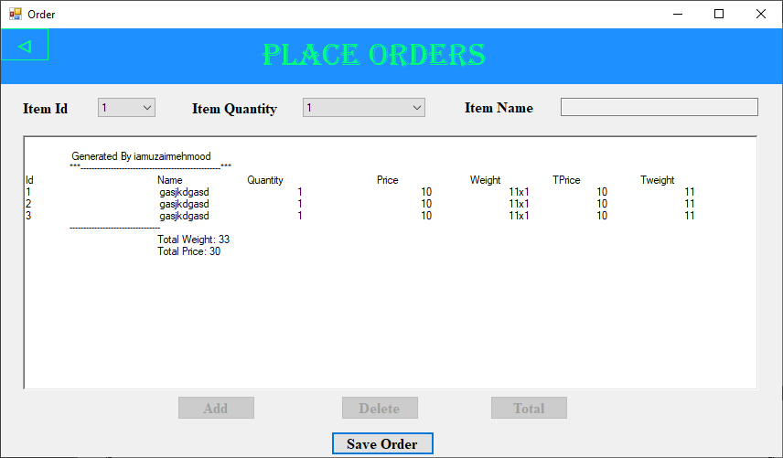

### Book_Order.cs

using System;

using System.Collections.Generic;

using System.ComponentModel;

using System.Data;

using System.Drawing;

using System.Linq;

using System.Text;

using System.Threading.Tasks;

using System.Windows.Forms;

using System.Data.SqlClient;

namespace SM_Management_System_DBMS

{

public partial class Book_Order : Form

{

public static string name;

public Book_Order()

{

InitializeComponent();

}

private void Book_Order_Load(object sender, EventArgs e)

{

display_orders();

}

private void textBox_search_TextChanged(object sender, EventArgs e)

{

search_orders();

}

public void search_orders()

{

using (SqlConnection sqlcon = new SqlConnection(Starting_form.con))

{

sqlcon.Open();

SqlDataAdapter sqlda = new SqlDataAdapter("exec pro_search_orders'" + textBox_search.Text + "'", sqlcon);

DataTable dtbl = new DataTable();

sqlda.Fill(dtbl);

dataGridView1.DataSource = dtbl;

sqlcon.Close();

}

}

private void button_add_Click(object sender, EventArgs e)

{

add_orders();

display_orders();

}

public void add_orders()

{

using (SqlConnection sqlcon = new SqlConnection(Starting_form.con))

{

sqlcon.Open();

SqlDataAdapter sqlda = new SqlDataAdapter("exec pro_insert_orders'" + textBox_name.Text + "','" + dateTimePicker1.Text + "','" + Order.totalweight + "','" +Order.totalprice + "'", sqlcon);

DataTable dtbl = new DataTable();

sqlda.Fill(dtbl);

dataGridView1.DataSource = dtbl;

sqlcon.Close();

Order.totalprice = 0;

Order.totalweight = 0;

name = textBox_name.Text;

}

}

public void update_orders()

{

using (SqlConnection sqlcon = new SqlConnection(Starting_form.con))

{

sqlcon.Open();

SqlDataAdapter sqlda = new SqlDataAdapter("exec pro_update_orders'"+textBox_id.Text+"','" + textBox_name.Text + "','" + dateTimePicker1.Text + "','" + Order.totalweight + "','" + Order.totalprice + "'", sqlcon);

DataTable dtbl = new DataTable();

sqlda.Fill(dtbl);

dataGridView1.DataSource = dtbl;

sqlcon.Close();

}

}

public void delete_orders()

{

using (SqlConnection sqlcon = new SqlConnection(Starting_form.con))

{

sqlcon.Open();

SqlDataAdapter sqlda = new SqlDataAdapter("exec pro_delete_orders'" + textBox_id.Text + "'", sqlcon);

DataTable dtbl = new DataTable();

sqlda.Fill(dtbl);

dataGridView1.DataSource = dtbl;

sqlcon.Close();

}

}

public void display_orders()

{

using (SqlConnection sqlcon = new SqlConnection(Starting_form.con))

{

sqlcon.Open();

SqlDataAdapter sqlda = new SqlDataAdapter("exec pro_show_orders", sqlcon);

DataTable dtbl = new DataTable();

sqlda.Fill(dtbl);

dataGridView1.DataSource = dtbl;

sqlcon.Close();

}

}

private void button_delete_Click(object sender, EventArgs e)

{

delete_orders();

display_orders();

}

private void button_update_Click(object sender, EventArgs e)

{

update_orders();

display_orders();

}

private void button_display_Click(object sender, EventArgs e)

{

display_orders();

}

private void button_back_Click(object sender, EventArgs e)

{

this.Hide();

Order order = new Order();

order.Show();

}

private void textBox_id_TextChanged(object sender, EventArgs e)

{

}

private void textBox_id_KeyPress(object sender, KeyPressEventArgs e)

{

if (!Char.IsDigit(e.KeyChar) && !char.IsControl(e.KeyChar))

e.Handled = true;

}

private void textBox_name_KeyPress(object sender, KeyPressEventArgs e)

{

if (!char.IsLetter(e.KeyChar) && !char.IsControl(e.KeyChar) && !char.IsWhiteSpace(e.KeyChar))

e.Handled = true;

}

private void button1_Click(object sender, EventArgs e)

{

this.Hide();

Home_Delivery HOME_DELIVERY = new Home_Delivery();

HOME_DELIVERY.Show();

}

private void textBox_search_KeyPress(object sender, KeyPressEventArgs e)

{

if (!char.IsLetter(e.KeyChar) && !char.IsControl(e.KeyChar) && !char.IsWhiteSpace(e.KeyChar))

e.Handled = true;

}

}

}

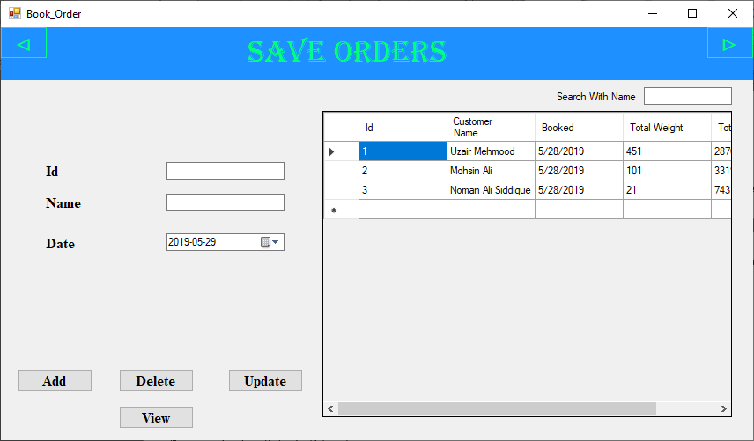

### Home_Delivery.cs

using System;

using System.Collections.Generic;

using System.ComponentModel;

using System.Data;

using System.Drawing;

using System.Linq;

using System.Text;

using System.Threading.Tasks;

using System.Windows.Forms;

using System.Data.SqlClient;

namespace SM_Management_System_DBMS

{

public partial class Home_Delivery : Form

{

int orderid;

string name, date;

public Home_Delivery()

{

InitializeComponent();

}

private void Home_Delivery_Load(object sender, EventArgs e)

{

display_delivery();

textBox_vehiclename.ReadOnly = true;

textBox_capacity.ReadOnly = true;

fill_combo();

search_delivery();

comboBox_vehicleId.DropDownStyle = ComboBoxStyle.DropDownList;

get_date_name();

get_last_order_id();

}

public void search_delivery()

{

using (SqlConnection sqlcon = new SqlConnection(Starting_form.con))

{

sqlcon.Open();

SqlDataAdapter sqlda = new SqlDataAdapter("exec pro_search_delivery'" + textBox_search.Text + "'", sqlcon);

DataTable dtbl = new DataTable();

sqlda.Fill(dtbl);

dataGridView1.DataSource = dtbl;

sqlcon.Close();

}

}

public void fill_combo()

{

try

{

using (SqlConnection sqlcon = new SqlConnection(Starting_form.con))

{

sqlcon.Open();

SqlDataAdapter sqlda = new SqlDataAdapter("select * from vehicles order by Id ASC", sqlcon);

DataTable dt1 = new DataTable();

sqlda.Fill(dt1);

//dataGridView1.DataSource = dt;

foreach (DataRow dr in dt1.Rows)

{

comboBox_vehicleId.Items.Add(dr["Id"].ToString());

}

sqlcon.Close();

}

}

catch (Exception e)

{

MessageBox.Show("Failed to Fill Vehicle Data", "Error", MessageBoxButtons.OK, MessageBoxIcon.Error);

}

}

public void fill_textbox()

{

using (SqlConnection sqlcon = new SqlConnection(Starting_form.con))

{

sqlcon.Open();

SqlDataAdapter sqlda = new SqlDataAdapter("select * from vehicles where Id = '" + comboBox_vehicleId.Text + "'", sqlcon);

DataTable dt2 = new DataTable();

sqlda.Fill(dt2);

//dataGridView1.DataSource = dt;

foreach (DataRow dr in dt2.Rows)

{

// comboBox_supplierid.Items.Add(dr["Id"].ToString());

textBox_vehiclename.Text = dr["Name"].ToString();

textBox_capacity.Text = dr["Max Load"].ToString();

}

sqlcon.Close();

}

}

private void comboBox_vehicleId_MouseUp(object sender, MouseEventArgs e)

{

fill_textbox();

}

private void comboBox_vehicleId_MouseHover(object sender, EventArgs e)

{

fill_textbox();

}

private void comboBox_vehicleId_MouseLeave(object sender, EventArgs e)

{

fill_textbox();

}

private void comboBox_vehicleId_MouseMove(object sender, MouseEventArgs e)

{

fill_textbox();

}

private void comboBox_vehicleId_MouseEnter(object sender, EventArgs e)

{

fill_textbox();

}

private void comboBox_vehicleId_MouseDown(object sender, MouseEventArgs e)

{

fill_textbox();

}

public void get_last_order_id()

{

using (SqlConnection sqlcon = new SqlConnection(Starting_form.con))

{

string id;

sqlcon.Open();

SqlDataAdapter sqlda = new SqlDataAdapter("select * from orders order by Id DESC", sqlcon);

DataTable getid = new DataTable();

sqlda.Fill(getid);

DataRow row = getid.Rows[0];

id = row["Id"].ToString();

orderid = int.Parse(id);

//dataGridView1.DataSource = dt;

sqlcon.Close();

}

}

public void get_date_name()

{

using (SqlConnection sqlcon = new SqlConnection(Starting_form.con))

{

sqlcon.Open();

SqlDataAdapter sqlda = new SqlDataAdapter("select * from orders where Id = '" +orderid+ "'", sqlcon);

DataTable dt3 = new DataTable();

sqlda.Fill(dt3);

//dataGridView1.DataSource = dt;

foreach (DataRow dr in dt3.Rows)

{

// comboBox_supplierid.Items.Add(dr["Id"].ToString());

name = dr["[Customer Name]"].ToString();

date = dr["Booked"].ToString();

}

sqlcon.Close();

}

}

public void add_delivery()

{

try

{

using (SqlConnection sqlcon = new SqlConnection(Starting_form.con))

{

int max_load = Convert.ToInt32(textBox_capacity.Text);

if (max_load > Order.totalweight)

{

sqlcon.Open();

SqlDataAdapter sqlda = new SqlDataAdapter("exec pro_insert_delivery'" + orderid + "','" + comboBox_vehicleId.Text + "','" + Order.name + "','" + textBox_phonenumber.Text + "','" + textBox_address.Text + "','" + date + "','" + Login.username + "'", sqlcon);

DataTable dtbl = new DataTable();

sqlda.Fill(dtbl);

dataGridView1.DataSource = dtbl;

sqlcon.Close();

}

else

{

MessageBox.Show("Vehicle Over Loaded", "Overload", MessageBoxButtons.OK, MessageBoxIcon.Information);

}

}

}

catch (Exception e)

{

MessageBox.Show("Select Vehicle Id","Error",MessageBoxButtons.OK,MessageBoxIcon.Error);

}

}

public void delete_delivery()

{

using (SqlConnection sqlcon = new SqlConnection(Starting_form.con))

{

sqlcon.Open();

SqlDataAdapter sqlda = new SqlDataAdapter("exec pro_delete_delivery'" + textBox_id.Text + "'", sqlcon);

DataTable dtbl = new DataTable();

sqlda.Fill(dtbl);

dataGridView1.DataSource = dtbl;

sqlcon.Close();

}

}

private void textBox_id_KeyPress(object sender, KeyPressEventArgs e)

{

if (!Char.IsDigit(e.KeyChar) && !char.IsControl(e.KeyChar))

e.Handled = true;

}

private void textBox_phonenumber_KeyPress(object sender, KeyPressEventArgs e)

{

if (!Char.IsDigit(e.KeyChar) && !char.IsControl(e.KeyChar))

e.Handled = true;

}

private void button_add_Click(object sender, EventArgs e)

{

add_delivery();

display_delivery();

}

private void button_delete_Click(object sender, EventArgs e)

{

delete_delivery();

display_delivery();

}

private void button_update_Click(object sender, EventArgs e)

{

update_delivery();

display_delivery();

}

private void button_display_Click(object sender, EventArgs e)

{

display_delivery();

}

public void update_delivery()

{

try

{

using (SqlConnection sqlcon = new SqlConnection(Starting_form.con))

{

sqlcon.Open();

SqlDataAdapter sqlda = new SqlDataAdapter("exec pro_update_delivery'" + textBox_id.Text + "','" + textBox_phonenumber.Text + "','" +textBox_address.Text+ "'", sqlcon);

DataTable dtbl = new DataTable();

sqlda.Fill(dtbl);

dataGridView1.DataSource = dtbl;

sqlcon.Close();

MessageBox.Show("Phone Number And Address Update");

}

}

catch (Exception e)

{

MessageBox.Show("Update Failed", "FAILURE", MessageBoxButtons.OK, MessageBoxIcon.Error);

}

}

private void textBox_search_KeyPress(object sender, KeyPressEventArgs e)

{

if (!char.IsLetter(e.KeyChar) && !char.IsControl(e.KeyChar) && !char.IsWhiteSpace(e.KeyChar))

e.Handled = true;

}

public void display_delivery()

{

using (SqlConnection sqlcon = new SqlConnection(Starting_form.con))

{

sqlcon.Open();

SqlDataAdapter sqlda = new SqlDataAdapter("exec pro_show_delivery", sqlcon);

DataTable dtbl = new DataTable();

sqlda.Fill(dtbl);

dataGridView1.DataSource = dtbl;

sqlcon.Close();

}

}

}

}

